

Android

Mobile app development

Bitra Pranavi | Samyutha Info Technologies| 21-May-2018

**ABSTRACT**

Android Studio is an integrated development environment (IDE) from Google that provides developers with tools needed to build applications for the Android OS platform. Android Studio is available for download on Windows, Mac and Linux.

Layout refers to defining how the View components are displayed on the screen relative to each other. A layout is typically defined partly by the View and partly by the ViewGroup which contains the View. As mentioned in View and ViewGroup a ViewGroup is a subclass of View which can itself contain View instances.

ListView is a view which groups several items and display them in vertical scrollable list. The list items are automatically inserted to the list using an Adapter that pulls content from a source such as an array or database.

GridView shows items in two-dimensional scrolling grid (rows & columns) and the grid items are not necessarily predetermined but they automatically inserted to the layout using a ListAdapter.

Fragment is a piece of an activity which enable more modular activity design. It will not be wrong if we say, a fragment is a kind of sub-activity.

SQLite is a opensource SQL database that stores data to a text file on a device. Android comes in with built in SQLite database implementation.

Retrofit is a REST Client for Android and Java by Square. It makes it relatively easy to retrieve and upload JSON (or other structured data) via a REST based webservice. In Retrofit you configure which converter is used for the data serialization.

Navigation drawer is a UI panel that shows your app's main navigation menu. It is hidden when not in use, but appears when the user swipes a finger from the left edge of the screen or, when at the top level of the app, the user touches the drawer icon in the app bar.

Swipe views provide lateral navigation between sibling screens such as tabs with a horizontal finger gesture.

**Contents**

**Android Studio** 4

**Android Studio Features** 5

**History** 5

**Layout** 8

**Adapter** 8

**Activity Lifecycle in Android** 10

**Layouts Demo** 12

**ListView Demo** 20

**ListView by using Model Class** 23

**GridView Demo** 27

**Fragment Demo** 29

**SQLite in Android** 36

**Retrofit** 45

**Navigation Drawer and Swipe Tabs** 63



# **Android Studio**

Android is a mobile operating system developed by Google. The Android operating system (OS) is based on the Linux kernel. Android is a mobile operating system which is found on a variety of modern devices, the most popular being smartphones. On top of that, you’ll also find Android on tablets, TV streaming boxes and other portable gadgets. Android is open source, meaning developers can modify and customize the OS for each phone. Android was released under the Apache v2 open source license.Therefore, different Android-based phones often have different graphical user interfaces GUIs even though they use the same OS.

Android is basically a piece of software which allows your hardware to function. The Android OS gives you access to apps, including many of Google’s own creation. These allow you to look for information on the web, play music and videos, check your location on a map, take photos using your device’s camera and plenty more besides.

Android phones typically come with several built-in applications and also support third-party programs. Developers can create programs for Android using the free Android software developer kit (SDK). Android programs are written in Java and run through a Java virtual machine JVM that is optimized for mobile devices. The "Dalvik" JVM was used through Android 4.4 and was replaced by Android Runtime or "ART" in Android 5.0. Users can download and install Android apps from Google Play and other locations. Android software development is the process by which new applications are created for devices running the Android operating system.

Android Studio is the official Integrated Development Environment (IDE) for Android app development, based on IntelliJ IDEA . The Android Studio IDE is free to download and use. It has a rich UI development environment with templates to give new developers a launching pad into Android development. Developers will find that Studio gives them the tools to build phone and tablet solutions as well as emerging technology solutions for Android TV, Android Wear, Android Auto, Glass and additional contextual models.

Android Studio is intended to be used by development teams as small as one person or as large as global teams. The Android Studio IDE can be linked to larger teams with GIT or similar version control services for larger teams. Mature Android developers will find tools that are necessary for large teams to deliver solutions rapidly to their customers. Android solutions can be developed using either Java or C++ in Android Studio. The workflow for Android Studio is built around the concept of continuous integration. Continuous Integration allows for teams to test their code each and every time a developer checks in their work. Issues can be captured and reported to the team immediately. The concept of continuously checking code provides actionable feedback to the developers with the goal of releasing versions of a mobile solution faster to the Google Play App Store.

# **Android Studio Features**

* A flexible Gradle-based build system
* A fast and feature-rich emulator
* A unified environment where you can develop for all Android devices
* Instant Run to push changes to your running app without building a new APK
* Code templates and GitHub integration to help you build common app features and import sample code
* Extensive testing tools and frameworks
* Lint tools to catch performance, usability, version compatibility, and other problems
* C++ and NDK support
* Built-in support for Google Cloud Platform, making it easy to integrate Google Cloud Messaging and App Engine

# **History**

The history and versions of android are interesting to know. The code names of android ranges from A to O currently, such as Aestro, Blender, Cupcake, Donut, Eclair, Froyo, Gingerbread, Honeycomb, Ice Cream Sandwitch, Jelly Bean, KitKat ,Lollipop,Marshmallow,Nougat,Oreo.

1) Initially, Andy Rubin founded Android Incorporation in Palo Alto, California, United States in October, 2003.

2) In 17th August 2005, Google acquired android Incorporation. Since then, it is in the subsidiary of Google Incorporation.

3) The key employees of Android Incorporation are Andy Rubin, Rich Miner, Chris White and Nick Sears.

4) Originally intended for camera but shifted to smart phones later because of low market for camera only.

5) Android is the nick name of Andy Rubin given by coworkers because of his love to robots.

6) In 2007, Google announces the development of android OS.

7) In 2008, HTC launched the first android mobile.

API Level is an integer value that uniquely identifies the framework API revision offered by a version of the Android platform.

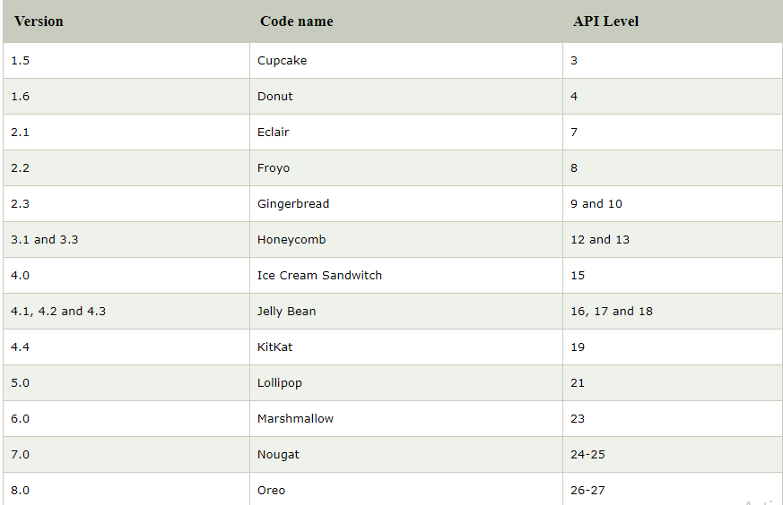 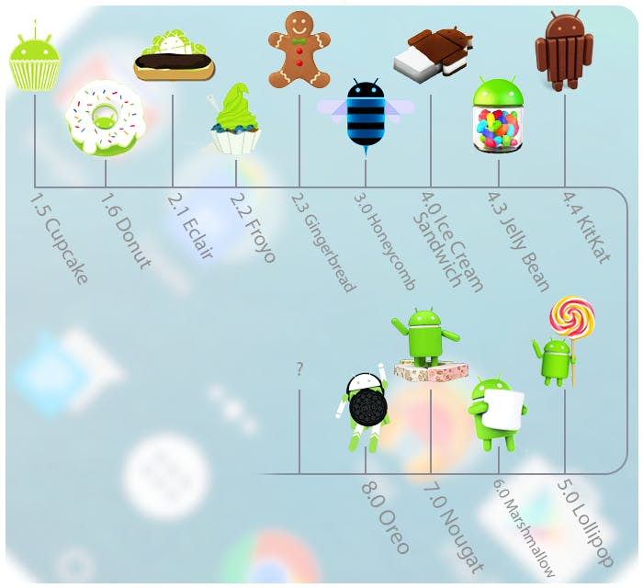

# **Layout**

Layout are used to define the actual UI(User interface) of our application. It holds all the elements (i.e. views) or the tools that we want to use in our application. For example, TextView, Button and other UI elements.

Types Of Layout And Few Important ViewGroup In Android

* Linear Layout
* Relative Layout
* Table Layout
* FrameLayout
* Absolute Layout
* ListView
* GridView

# **Adapter**

Adapter acts as a bridge between UI component and data source that helps us to fill data in UI component. It holds the data and send the data to an Adapter view then view can takes the data from the adapter view and shows the data on different views like as ListView, GridView, Spinner etc.

Different types of Adapter in Android:

* BaseAdapter
* SimpleAdapter
* Custom SimpleAdapter
* ArrayAdapter
* BaseAdapter

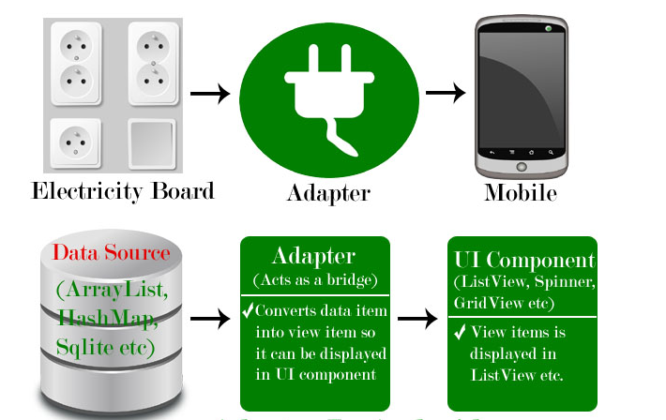

The whole concept of Android User Interface is defined using the hierarchy of View and ViewGroup objects. A ViewGroup is an invisible container that organizes child views. These child views are other widgets which are used to make the different parts of UI.

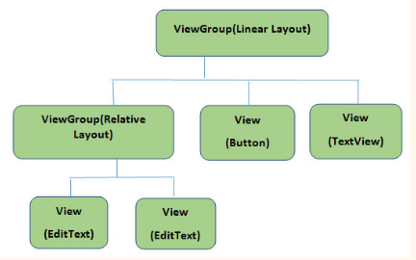

# **Activity Lifecycle in Android**

Activity is one of the building blocks of Android OS. In simple words Activity is a screen that user interact with. Every Activity in android has lifecycle like created, started, resumed, paused, stopped or destroyed. These different states are known as Activity Lifecycle. In other words we can say Activity is a class pre-written in Java Programming.

1. Short description of Activity Lifecycle example:

* onCreate() – Called when the activity is first created
* onStart() – Called just after it’s creation or by restart method after onStop(). Here Activity start becoming visible to user
* onResume() – Called when Activity is visible to user and user can interact with it
* onPause() – Called when Activity content is not visible because user resume previous activity
* onStop() – Called when activity is not visible to user because some other activity takes place of it
* onRestart() – Called when user comes on screen or resume the activity which was stopped
* onDestroy() – Called when Activity is not in background

1. Below is Activity Lifecycle Table:

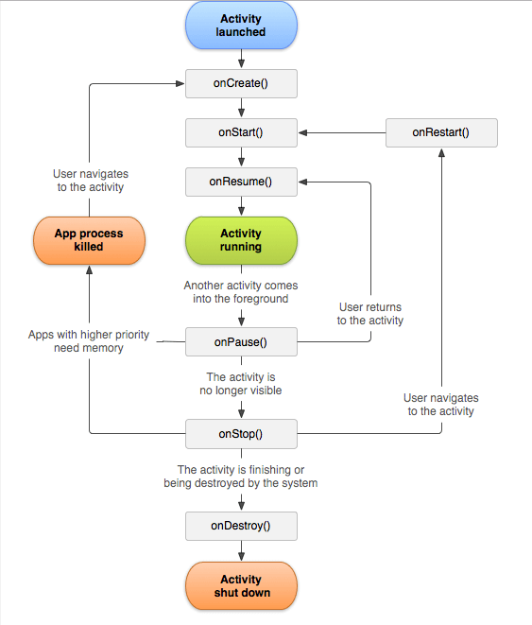

# **Layouts Demo**

Linear layout is a simple layout used in android for layout designing. In the Linear layout all the elements are displayed in linear fashion means all the childs/elements of a linear layout are displayed according to its orientation. The value for orientation property can be either horizontal or vertical.

There are two types of linear layout orientation:

* Vertical
* Horizontal

Relative Layout is very flexible layout used in android for custom layout designing and enables you to specify how child views are positioned relative to each other. The position of each view can be specified as relative to sibling elements or relative to the parent.

Difference between Linear And Relative Layout:

RELATIVE LAYOUT:

* Every element of relative layout arranges itself to the other element or a parent element.
* It is helpful while adding views one next to other etc
* In a relative layout you can give each child a Layout Property that specifies exactly where it should go in relative to the parent or relative to other children.
* Views can be layered on top of each other.

LINEAR LAYOUT:

* In a linear layout, like the name suggests, all the elements are displayed in a linear fashion either vertically or horizontally.
* Either Horizontally or Vertically this behavior is set in android:orientation which is an property of the node Linear Layout.
* Linear layouts put every child, one after the other, in a line, either horizontally or vertically.

TextView

TextView displays text to the user and optionally allows them to edit it programmatically. TextView is a complete text editor, however basic class is configured to not allow editing but we can edit it.

First you have to define TextView asking username and password of the user. The password TextView must have inputType set to password.

EditText

EditText is a standard entry widget in android apps. It is an overlay over TextView that configures itself to be editable. EditText is a subclass of TextView with text editing operations. We often use EditText in our applications in order to provide an input or text field, especially in forms.

ImageView

ImageView class is used to display an image file in application. ImageView comes with different configuration options to support different scale types.

Clipart

To add an icon for displaying at the right side.

Right-click the res > drawable folder in the Explorer area on the left of Android Studio. From the menu that appears, select New > Vector Asset:

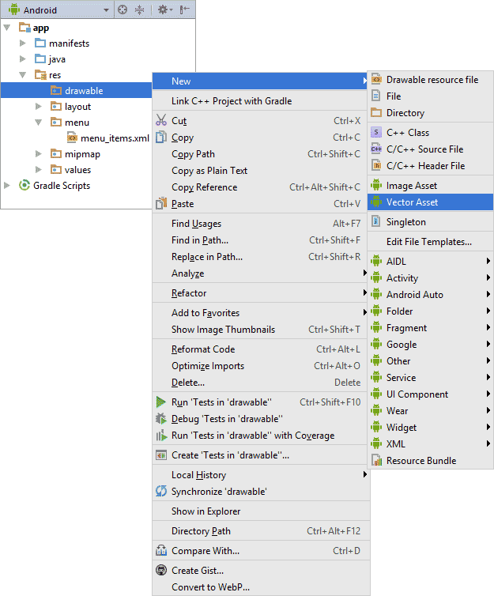

When you click on Vector Asset, you'll see the Configure Vector Asset dialogue box appear and click on Icon Clipart and Select your choice.

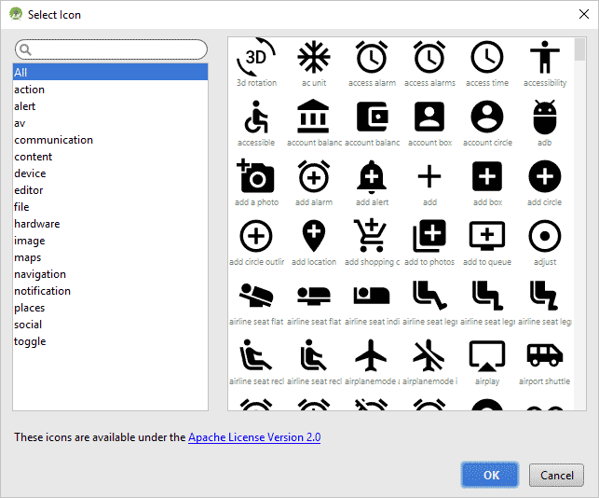

Button

Button represents a push button. A Push buttons can be clicked, or pressed by the user to perform an action.

Images are used in android application to add-on more user friendly behavior & functionality.

In this you need to follow this path to reach the desired folder.

app-> res -> drawable

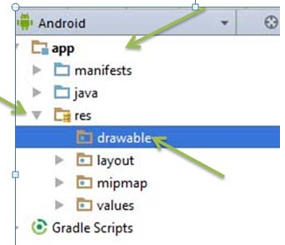

- Copy the images you want to add and right click on drawable folder. Further click on paste, your images are inserted in the folder & use them as per requirement.

All of those are saved as XML files and can be seen in the Design of Android Studio.

Now we have to write the Java code to perform the actions defined in the design.

The main activity code is a Java file MainActivity.java. This is the actual application file which ultimately gets converted to a Dalvik executable and runs your application.

Here, R.layout.activity_main refers to the activity_main.xml file located in the res/layout folder. The onCreate() method is one of many methods that are figured when an activity is loaded.

Whatever component you develop as a part of your application, you must declare all its components in a manifest.xml which resides at the root of the application project directory. This file works as an interface between Android OS and your application.

In Register activity we have to cast the objects created for the design views and for the button use onClickListener() method using Intents

Android uses Intent for communicating between the components of an Application and also from one application to another application.

**Intents**

Intent are the objects which is used in android for passing the information among Activities in an Application and from one app to another also. Intent are used for communicating between the Application components and it also provides the connectivity between two apps.

Intent intent = new Intent(getApplicationContext(), SecondActivity.class);

startActivity(intent);

Types of Intents:

Intent are of two types: Explicit Intent and Implicit Intent

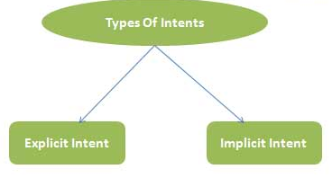

Explicit Intent:

Explicit Intents are used to connect the application internally.

In Explicit we use the name of component which will be affected by Intent. For Example: If we know class name then we can navigate the app from One Activity to another activity using Intent. In the similar way we can start a service to download a file in background process.

Implicit Intent:

In Implicit Intents we do need to specify the name of the component. We just specify the Action which has to be performed and further this action is handled by the component of another application.

The basic example of implicit Intent is to open any web page.

Intent Uses In Android:

Android uses Intents for facilitating communication between its components like Activities, Services and Broadcast Receivers.

Intent for an Activity:

Every screen in Android application represents an activity. To start a new activity you need to pass an Intent object to startActivity() method. This Intent object helps to start a new activity and passing data to the second activity.

Intent for Services:

Services work in background of an Android application and it does not require any user Interface. Intents could be used to start a Service that performs one-time task(for example: Downloading some file) or for starting a Service you need to pass Intent to startService() method.

Intent for Broadcast Receivers:

There are various message that an app receives, these messages are called as Broadcast Receivers. (For example, a broadcast message could be initiated to intimate that the file downloading is completed and ready to use). Android system initiates some broadcast message on several events, such as System Reboot, Low Battery warning message etc.

**OUTPUT:**

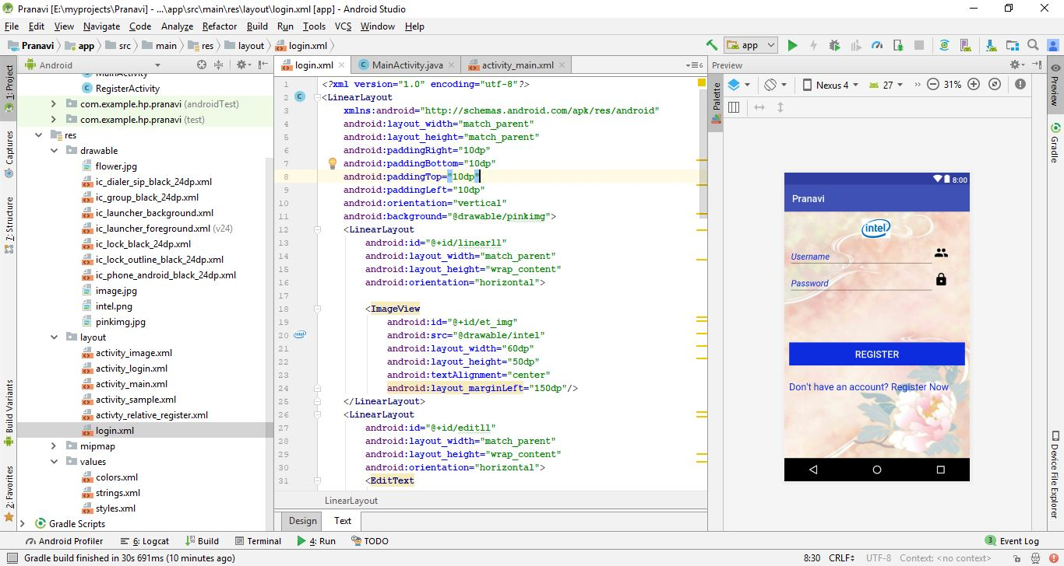

If you have a Login Account enter your details.

If you don’t have an account click on **Register Now!** And you will be directed to the Register page by the help of Intents.

After you have registered click on **Login Now!** To go to Login page

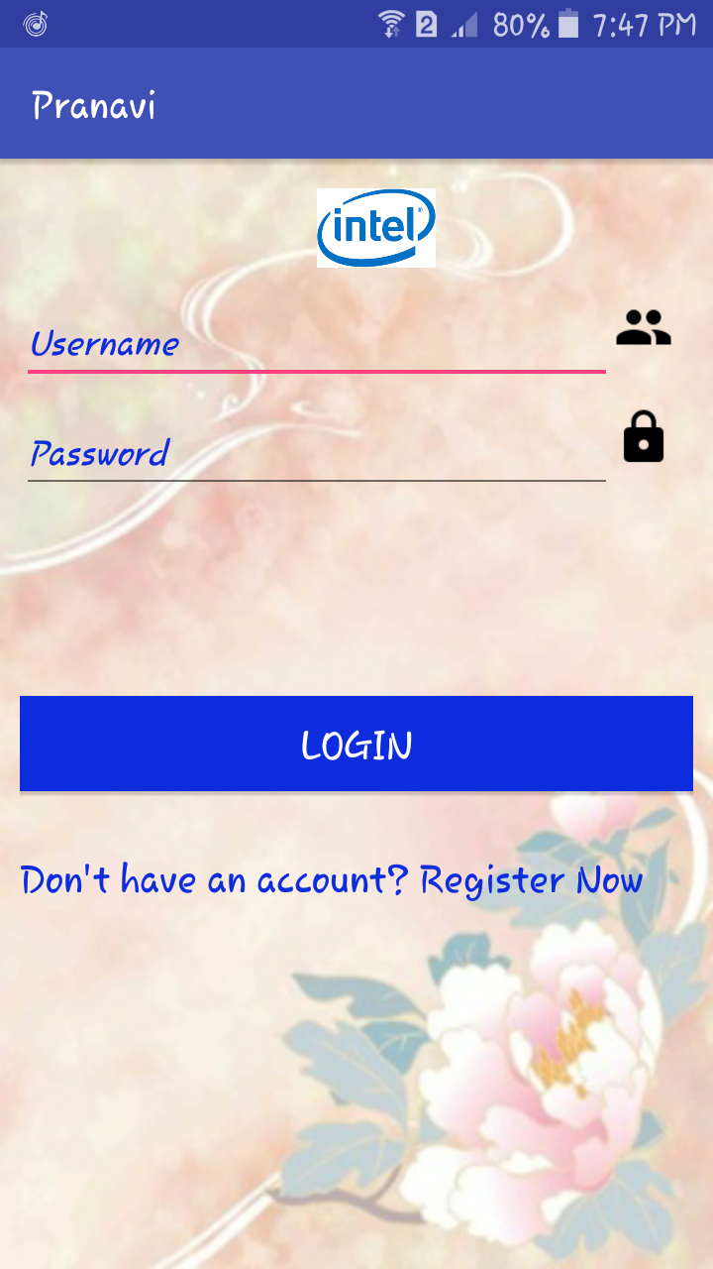 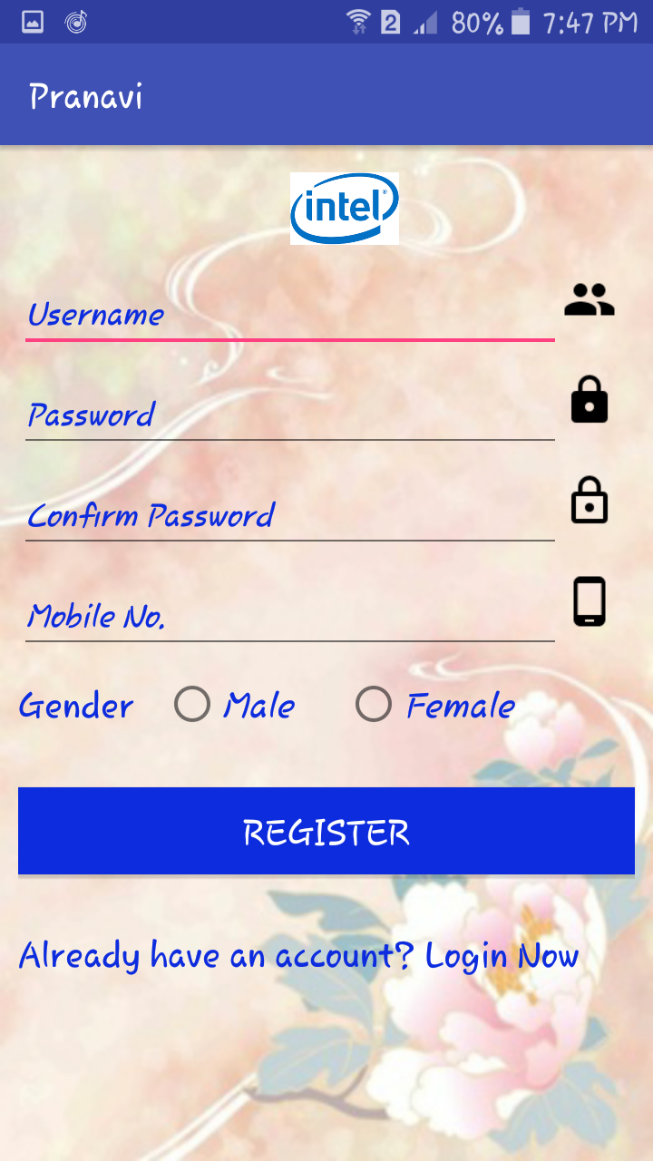

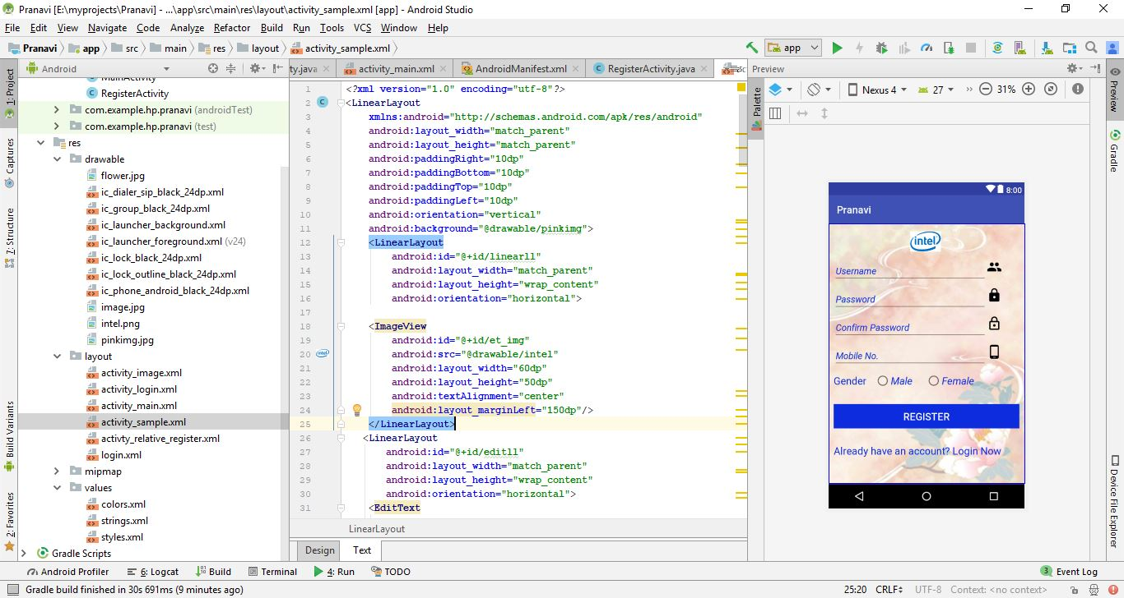

# **ListView Demo**

List of scrollable items can be displayed in Android using ListView. It helps you to displaying the data in the form of a scrollable list. Users can then select any list item by clicking on it. ListView is default scrollable so we do not need to use scroll View or anything else with ListView.

ListView is a view which groups several items and display them in vertical scrollable list. The list items are automatically inserted to the list using an Adapter that pulls content from a source such as an array or database.

ListView is widely used in android applications. A very common example of ListView is your phone contact book, where you have a list of your contacts displayed in a ListView and if you click on it then user information is displayed.

Listview with BaseAdapter

Create a new project Listview Demo and activity Main Activity. Here we will create a ListView in LinearLayout in the code of activity_main.xml

Create a new activity name Listview and write the code of activity_listview.xml.It consists of ImageView and TextView.

In third step we will use adapter to display the images and names in UI by coding MainActivity.java We create arrays to store static variables that includes Images and Names .We store the images in drawable folder.We create an adapter object and setAdapter() to the ListView

Adapters Use in ListView:

In android commonly used adapters are:

* Array Adapter
* Base Adapter

Now we explain these two adapter in detail:

1.Array Adapter:

Whenever you have a list of single items which is backed by an array, you can use ArrayAdapter. For instance, list of phone contacts, countries or names.

Below is Array Adapter code:

ArrayAdapter adapter = new ArrayAdapter<String>(this,R.layout.ListView,R.id.textView,StringArray);

2.Base Adapter:

BaseAdapter is a common base class of a general implementation of an Adapter that can be used in ListView. Whenever you need a customized list you create your own adapter and extend base adapter in that. Base Adapter can be extended to create a custom Adapter for displaying a custom list item. ArrayAdapter is also an implementation of BaseAdapter.

Now create another class Adapter which will extend BaseAdapter. Create an constuctor for the adapter class.

Context

Context is a handle to the system, it provides services like resolving resources, obtaining access to databases and preferences, and so on. An Android app has activities. It’s like a handle to the environment your application is currently running in. The activity object inherits the Context object. It allows access to application specific resources and class and information about the application environment. It is an instance which is the singleton and can be accessed in an activity via getApplicationContext(). This context is tied to the lifecycle of an application.

LayoutInflater

LayoutInflater class is used to instantiate layout XML file into its corresponding View objects.In other words, it takes as input an XML file and builds the View objects from it.

LayoutInflater is used to create a new View (or Layout) object from one of your xml layouts.

findViewById just gives you a reference to a view than has already been created. You might think that you haven't created any views yet, but whenever you call setContentView in onCreate, the activity's layout along with its subviews gets inflated (created) behind the scenes.

So if the view already exists, then use findViewById. If not, then create it with a LayoutInflater.

The Override methods will be implemented automatically by pressing Alt+Enter buttons simultaneously

getCount(),getItem(),getItemId(),getView()

public View getView(int position, View convertView, ViewGroup parent) {

convertView=inflater.inflate(R.layout.activity_listview,null);

Now let's inflate (create) another copy of our custom layout and add it in.

Set the TextView by using convertView,ImageView using setImageResource(image[position])

Now run the App in Emulator and it will show you the output

**OUTPUT:**

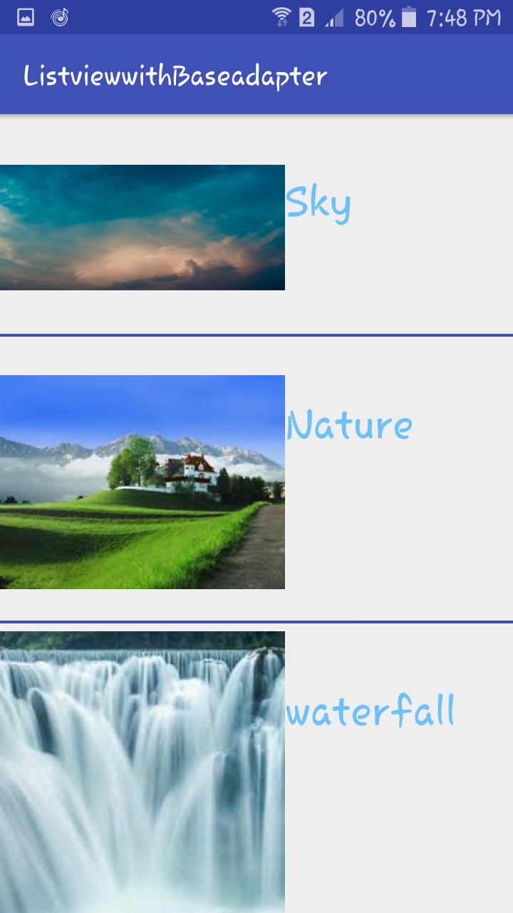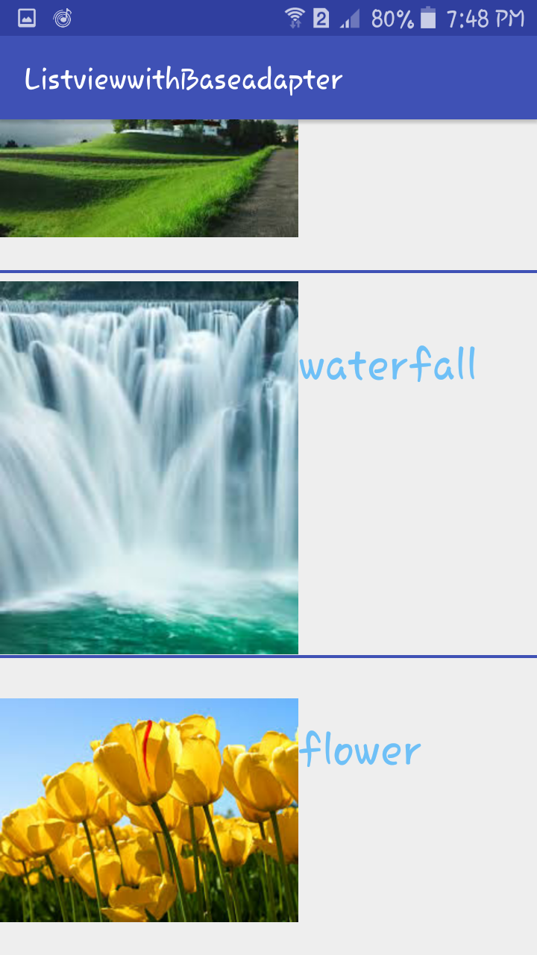

# **ListView by using Model Class**

Create a new project ListviewModel Demo and activity Main Activity. Here we will create a ListView in LinearLayout in the code of activity_main.xml

Create a new activity name Listview and write the code of activity_listview.xml.It consists of ImageView and two TextViews.

In MainActivity.java we declare ListView variables List.

List<Model> is the viewgroup to store the values in the class an array implementation of the List interface and ArrayList instance is created to store in items.

The Model class would usually be a set of classes that hold your data and business logic like Image,Title,Description.

In model class, there are mainly three methods ---

* Constructor: It is a bridge between model and adapter class.
* Getter method: This method is used for getting values of any property.
* Setter method: This method is used for setting value of any property

We can automatically obtain the Setter and Getter methods by Highlighting the variables right click and select Generate and click Getter&Setter

So when user ask for an information though View so view goes to controller and controller notify the model. Then model give that information to controller and controller notify View about that information so the user can see that information.

Now we create adapter class for getting data from the model and show it on view for the user. An adapter acts as an overpass between an AdapterView and the underlying data for that view. The adapter provides access to the data items and is answerable for creating a view for each item in the data set. Adapters are a good way to connect a View with some kind of data source.Create adapter class and set it.

Now declare variables. There are mainly two variables “Context” and “ArrayList”.

Context is used for access to application-specific resources and classes, as well as calls for application-level operations such as launching activities, broadcasting and receiving intents, etc.

ArrayList provides resizable-array, which means that items can be added and removed from the list. It implements the List interface.

The ListView is a widget used extensively in Android applications to display data in a structured fashion. The ViewHolder pattern is a pattern that a developer can use to increase the speed at which their ListView renders data. The reason for this improvement is that the number of times which the findViewById method is invoked is drastically reduced, existing views do not have to be garbage collected and new views do not have to be inflated. The ‘position’ integer stores the position of the current item within the adapter’s data set. The ‘convertView’ field is a reference to the old view that we are planning to reuse.

Now we create Override methods

* MyViewHolder() ---> In this method we define view and get text view or image view from XML by their Id.
* Create a parameterized constructor ---> Constructor is the mediator between Adapter and Activity.
* onCreateViewHolder() ---> This method create view for user.
* onBindViewHolder() ---> This method bind data with list of items.
* getItemCount() ---> This method indicates how many items (or rows) are in the data set that will be presented in the AdapterView.

A getLayoutInflater() just gives "quick access to the LayoutInflater instance that the window retrieved from its Context" (from the documentation) by returning the LayoutInflater.

Similarly, getSystemService(Context.LAYOUT_INFLATER_SERVICE) is used to retrieve a LayoutInflater for inflating layout resources in this context.

So, actually there is NO difference between the two.

Thus we get the same output by doing it in different methods.

**OUTPUT:**

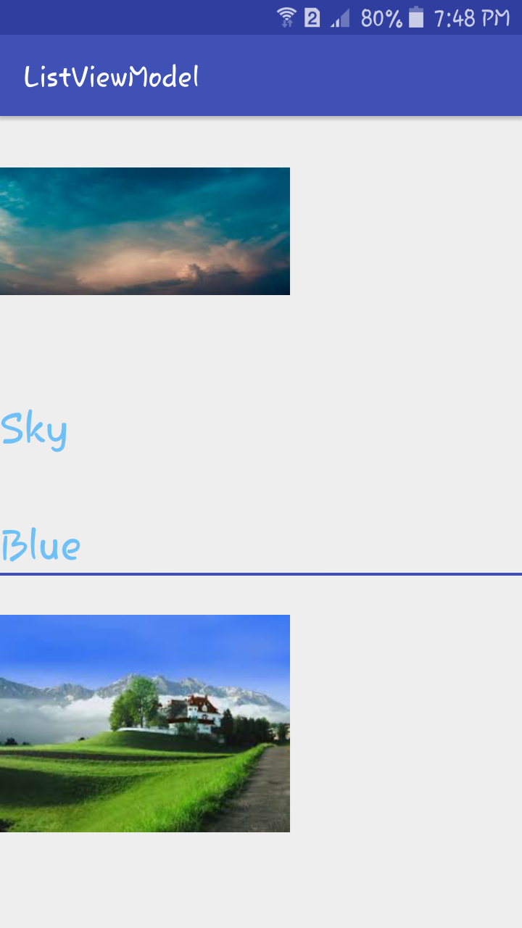 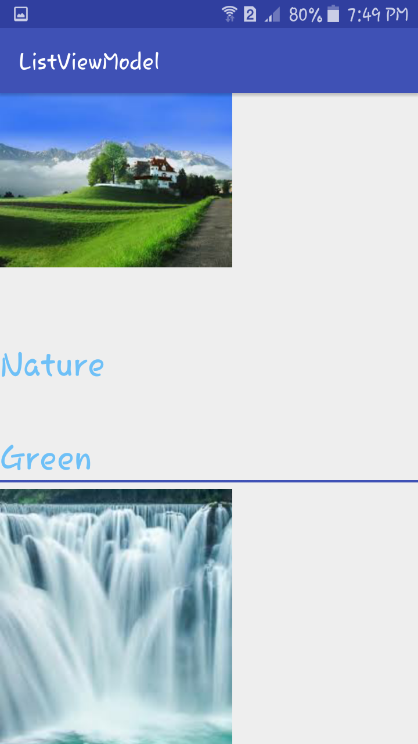

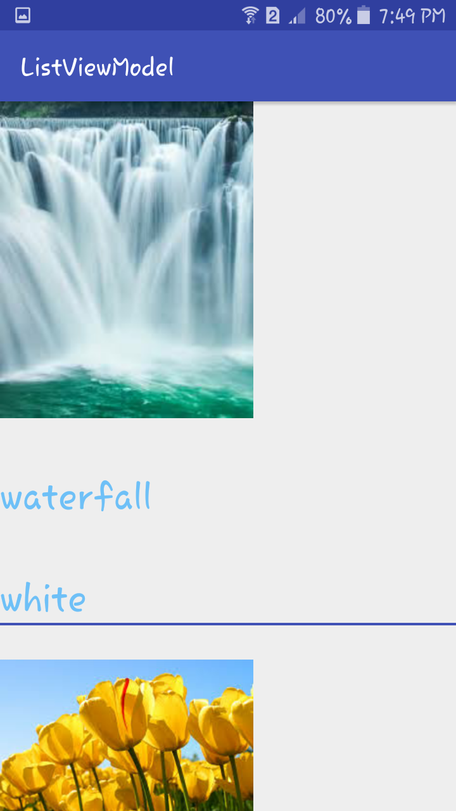 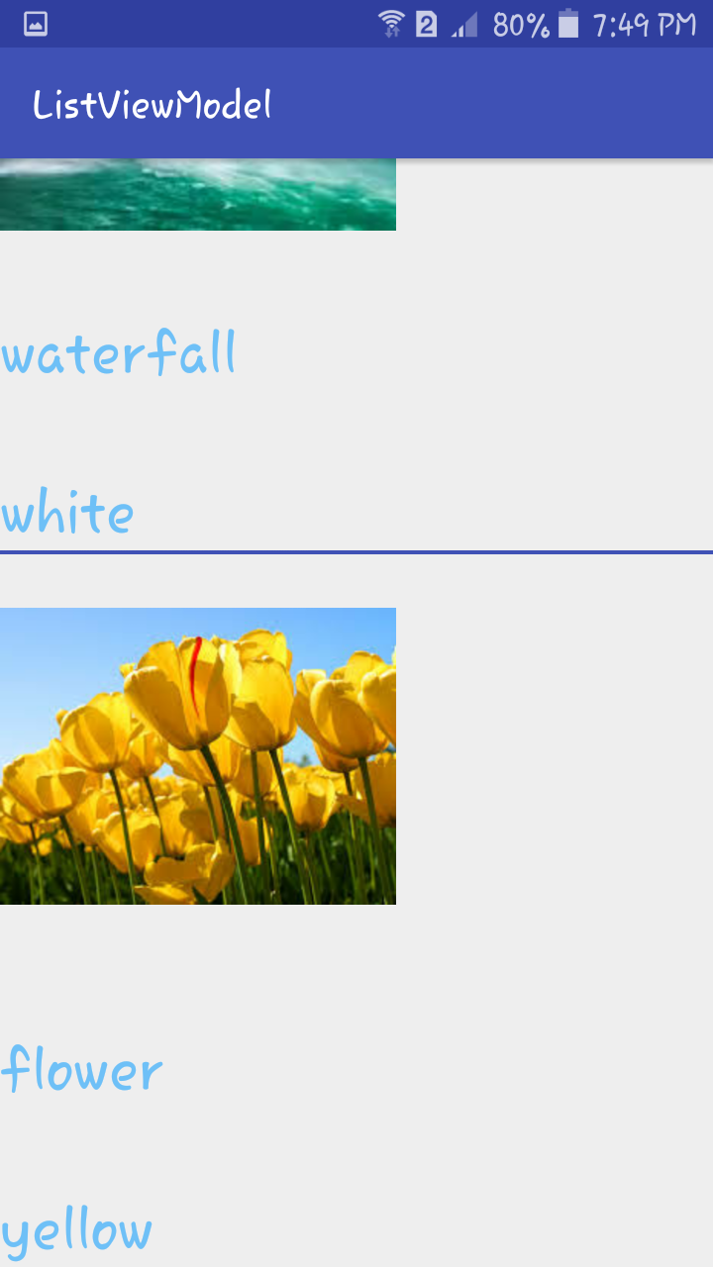

# **GridView Demo**

In android GridView is a view group that display items in two dimensional scrolling grid (rows and columns), the grid items are not necessarily predetermined but they are automatically inserted to the layout using a ListAdapter. Users can then select any grid item by clicking on it.

GridView shows items in two-dimensional scrolling grid (rows & columns) and the grid items are not necessarily predetermined but they automatically inserted to the layout using a ListAdapter

An example of GridView is your default Gallery, where you have number of images displayed using grid.

In the Layout we implement GridView and its atrributes.

* numColumns: numColumn define how many columns to show. It may be a integer value, such as “5” or auto_fit.

In another layout we implement ImageView and TextView.

In MainActivity.java we declare the String names[] and values , and object instance is found by R.id.givenname and create an adapter and setAdapter()

Adapter Is Used To Fill Data In Gridview: To fill the data in a GridView we simply use adapter and grid items are automatically inserted to a GridView using an Adapter which pulls the content from a source such as an arraylist, array or database.

GridView Using Base Adapter In Android:

Base Adapter is a common base class of a general implementation of an Adapter that can be used in GridView. Whenever you need a customized grid view you create your own adapter and extend base adapter in that. Base Adapter can be extended to create a custom Adapter for displaying custom grid items. ArrayAdapter is also an implementation of BaseAdapter.

LayoutInflater and convertView are utilized to display the images and text.

Now run the App and you will see different images in GridView.

**OUTPUT:**

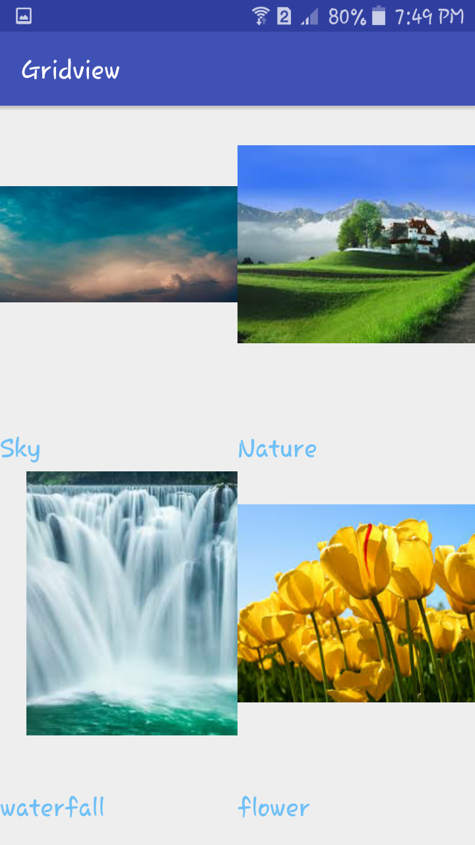

# **Fragment Demo**

Fragment is a part of an activity which enable more modular activity design. It will not be wrong if we say a fragment is a kind of sub-activity. It represents a behaviour or a portion of user interface in an Activity. We can combine multiple Fragments in Single Activity to build a multi panel UI and reuse a Fragment in multiple Activities. We always need to embed Fragment in an activity and the fragment lifecycle is directly affected by the host activity’s lifecycle. We can create Fragments by extending Fragment class or by inserting a Fragment into our Activity layout by declaring the Fragment in the activity’s layout file, as a <fragment> element. We can manipulate each Fragment independently, such as add or remove them.

While performing Fragment Transaction we can add a Fragment into back stack that’s managed by the Activity. back stack allow us to reverse a Fragment transaction on pressing Back button of device. For Example if we replace a Fragment and add it in back stack then on pressing the Back button on device it display the previous Fragment.

Some Important Points About Fragment In Android:

1. Fragments were added in Honeycomb version of Android i.e API version 11.

2. We can add, replace or remove Fragment’s in an Activity while the activity is running. For performing these operations we need a Layout(Relative Layout, FrameLayout or any other layout) in xml file and then replace that layout with the required Fragment.

3. Fragments has its own layout and its own behaviour with its own life cycle callbacks.

4. Fragment can be used in multiple activities.

5. We can also combine multiple Fragments in a single activity to build a multi-plane UI.

Need Of Fragments In Android:

Before the introduction of Fragment’s we can only show a single Activity on the screen at one given point of time so we were not able to divide the screen and control different parts separately. With the help of Fragment’s we can divide the screens in different parts and controls different parts separately.

By using Fragments we can comprise multiple Fragments in a single Activity. Fragments have their own events, layouts and complete life cycle. It provide flexibility and also removed the limitation of single Activity on the screen at a time.

Fragment Lifecycle

Android fragments have their own life cycle very similar to an android activity. This section briefs different stages of its life cycle.

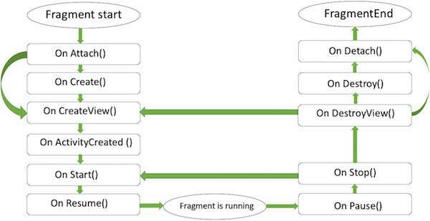

Here is the list of methods which you can to override in your fragment class −

* onAttach(): The fragment instance is associated with an activity instance.The fragment and the activity is not fully initialized. Typically you get in this method a reference to the activity which uses the fragment for further initialization work.
* onCreate(): The system calls this method when creating the fragment. You should initialize essential components of the fragment that you want to retain when the fragment is paused or stopped, then resumed.
* onCreateView() : The system calls this callback when it's time for the fragment to draw its user interface for the first time. To draw a UI for your fragment, you must return a View component from this method that is the root of your fragment's layout. You can return null if the fragment does not provide a UI.
* onActivityCreated(): The onActivityCreated() is called after the onCreateView() method when the host activity is created. Activity and fragment instance have been created as well as the view hierarchy of the activity. At this point, view can be accessed with the findViewById() method. example. In this method you can instantiate objects which require a Context object
* onStart(): The onStart() method is called once the fragment gets visible.
* onResume(): Fragment becomes active.
* onPause(): The system calls this method as the first indication that the user is leaving the fragment. This is usually where you should commit any changes that should be persisted beyond the current user session.
* onStop(): Fragment going to be stopped by calling onStop()
* onDestroyView(): Fragment view will destroy after call this method
* onDestroy(): It is called to do final clean up of the fragment's state but Not guaranteed to be called by the Android platform.

Implementation of Fragment In Android Require Honeycomb (3.0) or Later:

Fragments were added in in Honeycomb version of Android i.e API version 11. There are some primary classes related to Fragment’s are:

1. FragmentActivity: The base class for all activities using compatibility based Fragment (and loader) features.

2. Fragment: The base class for all Fragment definitions

3. FragmentManager: The class for interacting with Fragment objects inside an activity

4. FragmentTransaction: The class for performing an atomic set of Fragment operations such as Replace or Add a Fragment.

We create two Fragments and load them on the click of Button’s. We display two Button’s and a FrameLayout in our Activity and perform setOnClickListener event on both Button’s. On the click of First Button we replace the First Fragment and on click of Second Button we replace the Second Fragment with the layout(FrameLayout). In the both Fragment’s we display a TextView and a Button and onclick of Button we display the name of the Fragment with the help of Toast.

FRAGMENT DEMO

Create a new project and name it FragmentDemo

Open res -> layout ->activity_main.xml (or) main.xml

Frame Layout is one of the simplest layout to organize view controls. They are designed to block an area on the screen. Frame Layout should be used to hold child view, because it can be difficult to display single views at a specific area on the screen without overlapping each other.

We can add multiple children to a FrameLayout and control their position by assigning gravity to each child, using the android:layout_gravity attribute.

Open src -> package -> MainActivity.java

In this step we open MainActivity and add the code for initiate the Button’s. After that we perform setOnClickListener event on both Button’s. On the click of First Button we replace the First Fragment and on click of Second Button we replace the Second Fragment with the layout(FrameLayout). For replacing a Fragment with FrameLayout firstly we create a Fragment Manager and then begin the transaction using Fragment Transaction and finally replace the Fragment with the layout i.e FrameLayout.

Now we need 2 fragments and 2 xml layouts. So create two fragments by right click on your package folder and create classes and name them as FirstFragment and SecondFragment and add the following code respectively.

FirstFragment.class

In this Fragment firstly we inflate the layout and get the reference of Button. After that we perform setOnClickListener event on Button so whenever a user click on the button a message “First Fragment“ is displayed on the screen by using a Toast.

TOAST

Toast is used to display information for a period of time. It contains a message to be displayed quickly and disappears after specified period of time. It does not block the user interaction. Toast is a subclass of Object class. In this we use two constants for setting the duration for the Toast. Toast notification in android always appears near the bottom of the screen. We can also create our custom toast by using custom layout(xml file).

SecondFragment.class

In this Fragment firstly we inflate the layout and get the reference of Button. After that we perform setOnClickListener event on Button so whenever a user click on the button a message “Second Fragment“ is displayed on the screen by using a Toast.

Now create 2 xml layouts by right clicking on res/layout -> New -> Layout Resource File and name them as fragment_first and fragment_second and add the following code in respective files.

Here we will design the basic simple UI by using TextView and Button in both xml’s.

Now run the App and you will two button. Clicking on first button shows First Fragment and on click of Second Button shows the Second Fragment which is actually replacing layout(FrameLayout).

**OUTPUT:**

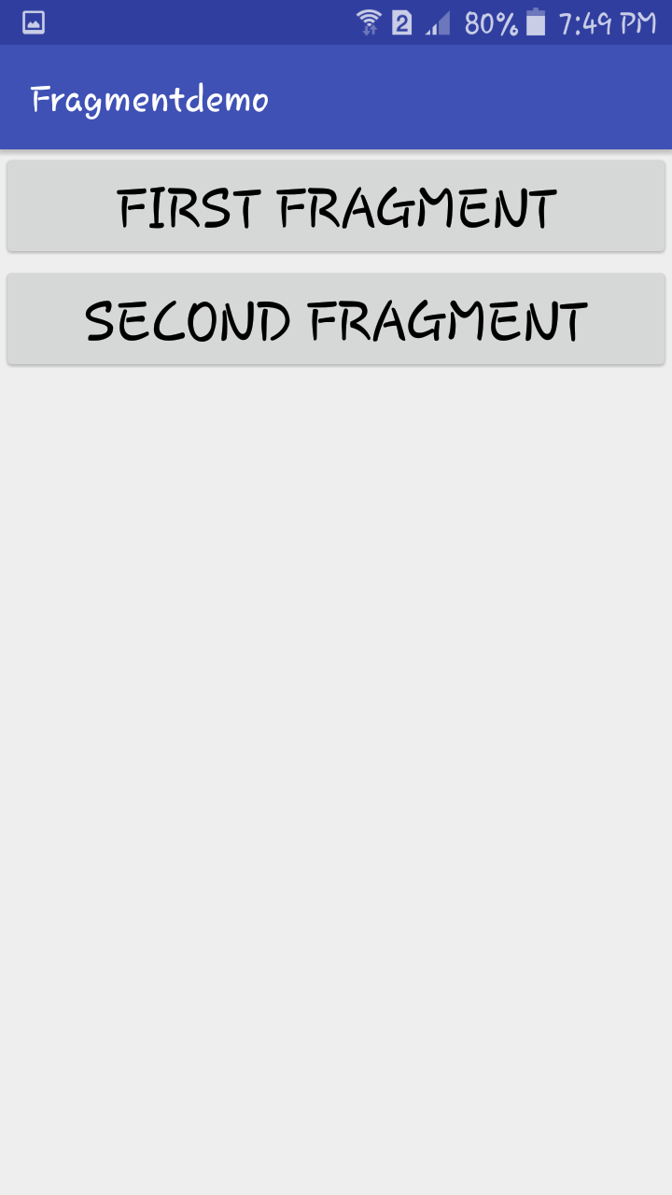 

Click on **FIRST FRAGMENT** and another attempt click on **SECOND FRAGMENT**

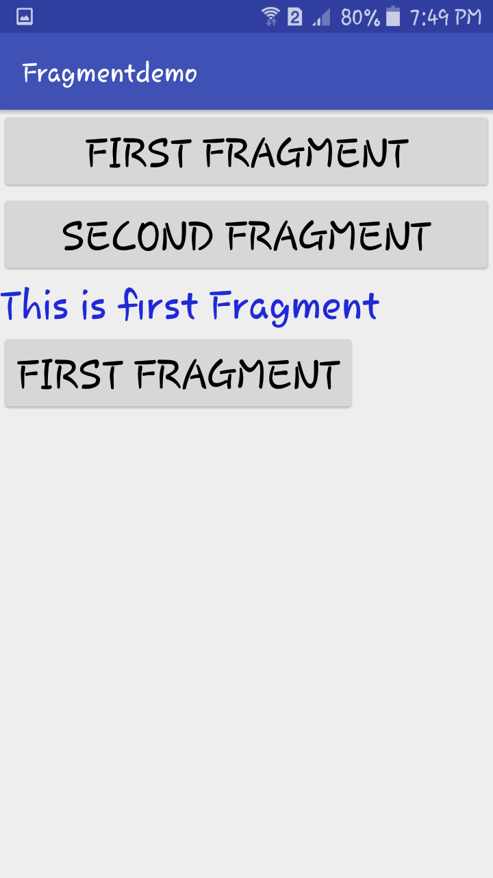 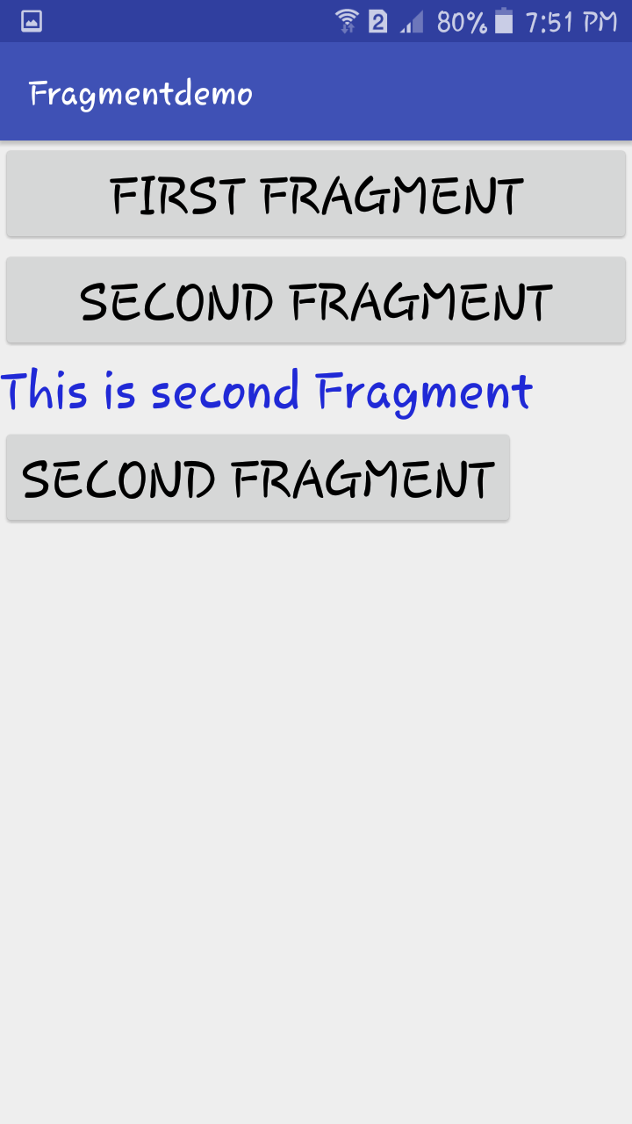

The text and another FIRST FRAGMENT button is displayed. Now Click on it.

It will display a TOAST as First Fragment at the bottom of the screen.

The text and another SECOND FRAGMENT button is displayed. Now Click on it.

It will display a TOAST as Second Fragment at the bottom of the screen.

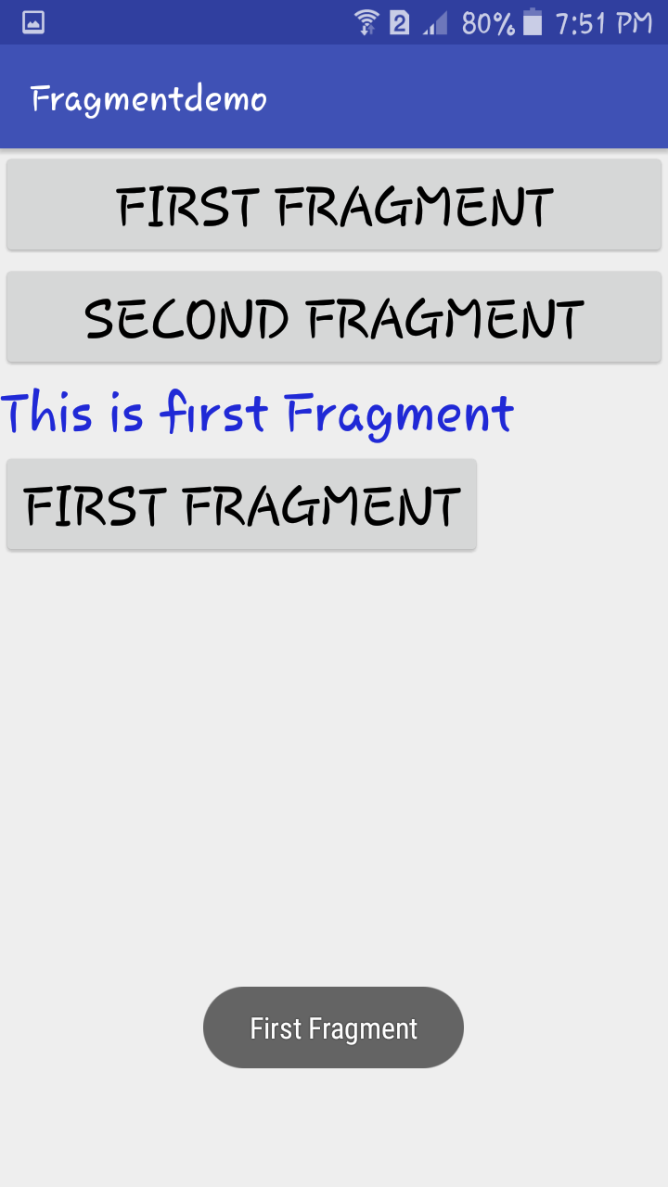 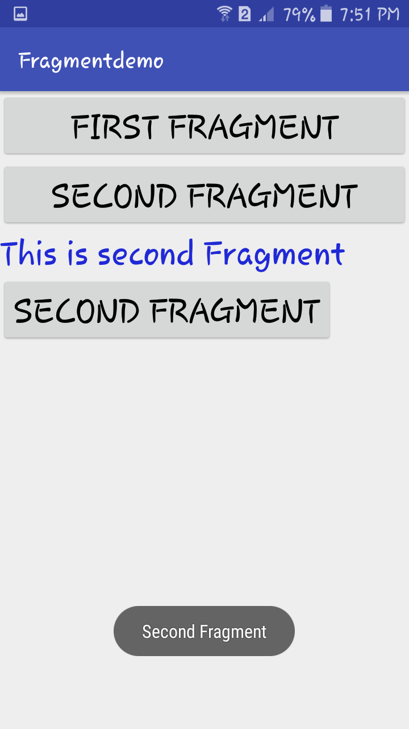

# **SQLite in Android**

SQLite is a Structure query base database, open source, light weight, no network access and standalone database. It support embedded relational database features.

Database - Package

The main package is android.database.sqlite that contains the classes to manage your own databases

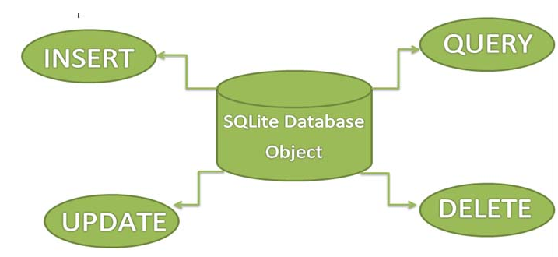

Whenever an application needs to store large amount of data then using sqlite is more preferable than other repository system like SharedPreferences or saving data in files.

Android has built in SQLite database implementation. It is available locally over the device(mobile & tablet) and contain data in text format. It carry light weight data and suitable with many languages. So, it doesn’t required any administration or setup procedure of the database.

Android provides different ways to store data locally so using SQLite is one the way to store data. SQLite is a structure query base database, hence we can say it’s a relation database. Android os has its own implementation to perform CRUD (Create, Read, Update, Delete)operations, so Android provides set of classes available in android.database and android.database.sqlite packages.

While using SQLite there could be two different ways to perform different operations like create, read, update and delete. One writing raw queries and another is using parameterized functions or we can say parametrized queries.

* Create: Creating a database is very simple in android by using SQLiteOpenHelper class. SQLiteOpenHelper is an abstract class with two abstract methods onCreate(SQLiteDatabase db) and onUpgrade(SQLiteDatabase db, int oldVersion, int newVersion) and many more database helpful functions.
* Insert: To perform insert operation using parameterized query we have to call insert function available in SQLiteDatabase class. insert() function has three parameters like public long insert(String tableName,String nullColumnHack,ContentValues values) where tableName is name of table in which data to be inserted.
* Update: Update function is quite similar to insert but it requires two additional parameters, it doesn’t required nullColumnHack. It has total four parameters two are similar to insert function that is tableName and contentValues. Another two are whereClause(String) and whereArgs(String[]).
* Delete: Similar to insert and update, delete function is available in SQLiteDatabase class, So delete is very similar to update function apart from ContentValues object as it’s not required in delete. public int delete(String tableName,String whereClause,String [] whereArgs) function has three parameters these are totally similar to update function’s parameters and are used in same way as in update function.
* Read(select): Reading from a database table is bit different from other functions like insert,update and delete. SQLiteDatabase class provides query() method to read data from table. query() method is overloaded with different set of parameters. It returns Cursor object so Cursor is a result-set with queried data, it provides different functions really helpful while reading data.

**SQLite Demo**

We simply want to illustrate the insert, update, delete and more operations of SQLite over a table in Android Studi. We created a activity having textview, button and edittext over it. Another class which extends SQLiteOpenHelper where the create and insert operations will be carried out. The example contain proper validation like you need to enter data before executing any operation.

Create a New Project and Name it SQLiteOperations.

Open res -> layout -> activity_main.xml (or) main.xml

In this step we create a layout in our XML file adding textbox, buttons, edittext. On button onclick is defined which associate it with related function.

Now open app -> java -> package -> MainActivity.java

We declare the variables and type casting it by using resourceb and ids of the components in the activity_main.xml.

We define the methods addUser() ,viewData(),delete() and update().

getApplicationContext() method returns the instance of Context.

In this step we used the functions that linked via the button click. These functions are defined in other class and are used here. Each function return value that define no of rows updated, using that we defined whether operation is successful or not. Also user need to define valid data to perform operation empty fields will not be entertained and return error .

In this step create a java class SqlAdapter. java.

In this we define the functions that are used to perform the operations insert, update and delete operations in SQLite. Further this class create another class that will extend the SQLiteOpenHelper. Each function carry equivalent methods that perform operations.

We have the methods like insertData(), getData(),delete(),updateName().

@Override which is used to tell the compiler that we’re overriding a method, it makes the code readable and maintainable, it also helps with avoiding issues when the signature of the method that we’re overriding is changed.

* onCreate(SQLiteDatabase sqLiteDatabase) method is called only for once throughout the application lifecycle, it will be called whenever there is first call to getReadableDatabase() or getWritableDatabase() function available in super SQLiteOpenHelper class so SQLiteOpenHelper class call the onCreate() method after creating database and instantiate SQLiteDatabase object. Database name is passed in constructor call.
* onUpgrade(SQLiteDatabase db,int oldVersion, int newVersion) is only called whenever there is a updation in existing version so to update a version we have to increment the value of version variable passed in the superclass constructor. In onUpgrade method we can write queries to perform whatever action is required. In most example you will see that existing table(s) are being dropped and again onCreate() method is being called to create tables again. But it’s not mandatory to do so it all depends upon your requirements. We have to change database version if we have added a new row in the database table in this case if we have requirement that we don’t want to lost existing data in the table then we can write alter table query in the onUpgrade(SQLiteDatabase db,int oldVersion, int newVersion) method.

Likewise if there is no requirement of existing data whenever we upgrade database version then we can write drop table query in onUpgrade(SQLiteDatabase db,int oldVersion, int newVersion) method and call onCreate(SQLiteDatabase sqLiteDatabase) method again to create table again. Remember never call onCreate(SQLiteDatabase sqLiteDatabase) method if you have written alter table query in onUpgrade(SQLiteDatabase db,int oldVersion, int newVersion) method.

In this step create another java class Message.class

In this just simply add toast for displaying message. This is optional, it is just added to again and again defining toast in the example.

Toast is a solution for android developer when required to notify user about an operation without expecting any user input.

This provides a small popup that displays for a small period and fades out automatically after timeout. Sometimes developers use this for debugging.

For example, some of the app shows “Press back once to Exit” message when pressed back button in home page. Another real-time example is Gmail app, It shows a Toast, when a mail message is saved to draft.

How to Create a Toast

We can instantiate a android.widget.Toast object using static makeText() method. This method takes three parameters: the application Context, the text message, and the duration for the toast. You can display the toast notification by calling show() method.

Toast notification in android always appears near the bottom of the screen, centered horizontally as shown in the image. However, it allows us to change its position with the setGravity(int, int, int) method. This accepts three parameters: a Gravity constant, an x-position offset, and a y-position offset.

Now run the app and view the functionality added over the buttons.

**OUTPUT:**

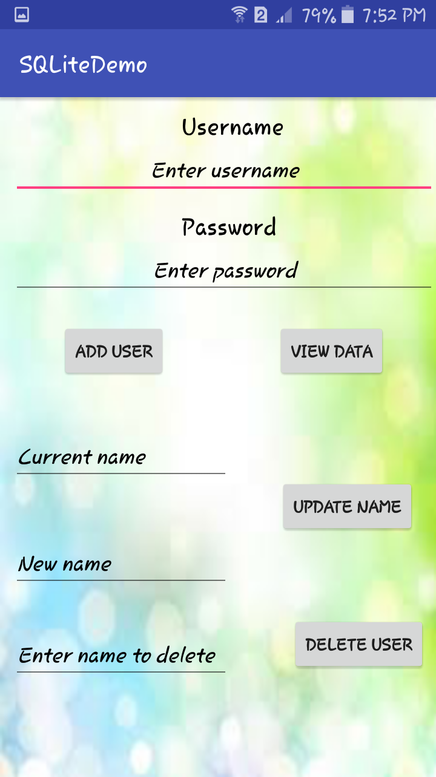

Enter Username and Password and click on **ADD USER.** It will display a Toast saying *Insertion Successful*

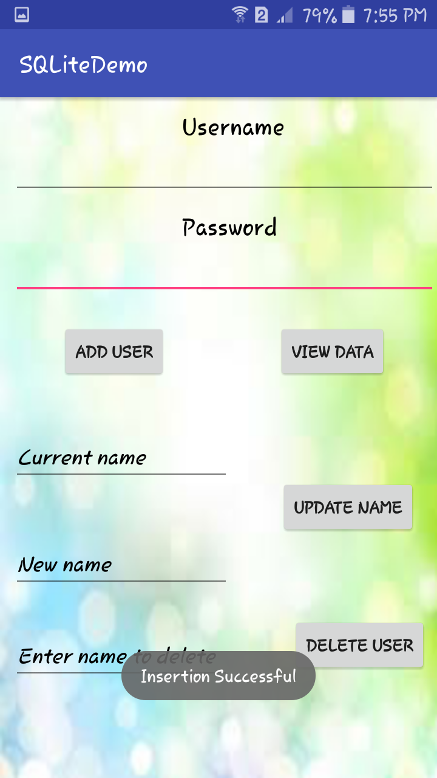

Click on **VIEW DATA** to display a Toast of the data stored in the SQLite Database of android.

And Insert more data to perform more operations

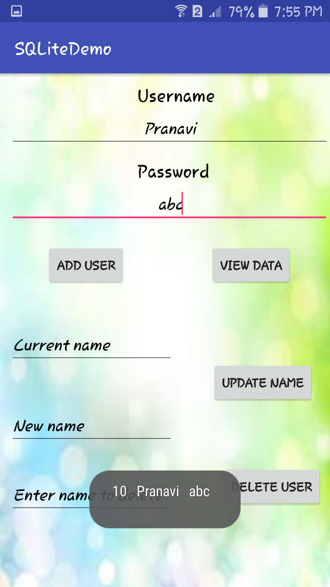 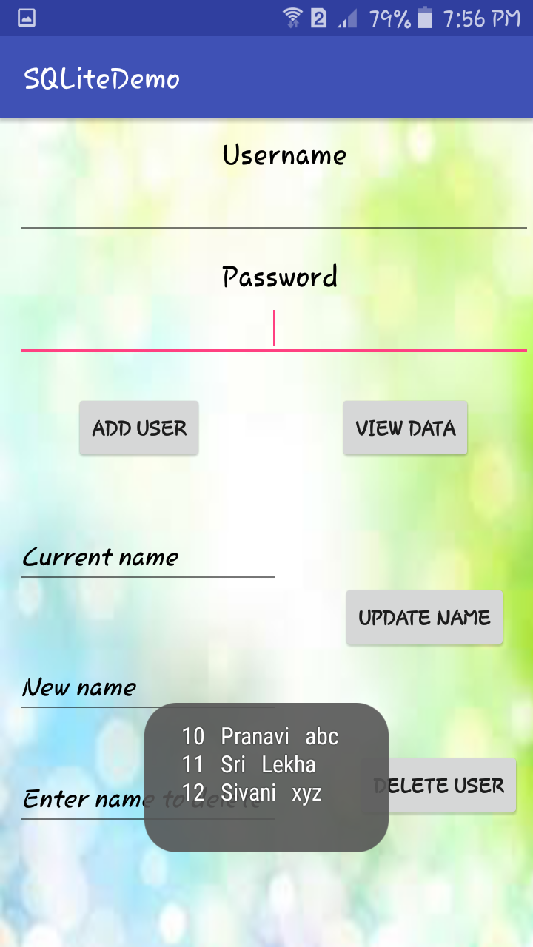

Perform **UPDATE NAME** by changing Current name ( Sivani ) to New name ( Vineesha ) . Click on the button. It will display a Toast as *Updated*.

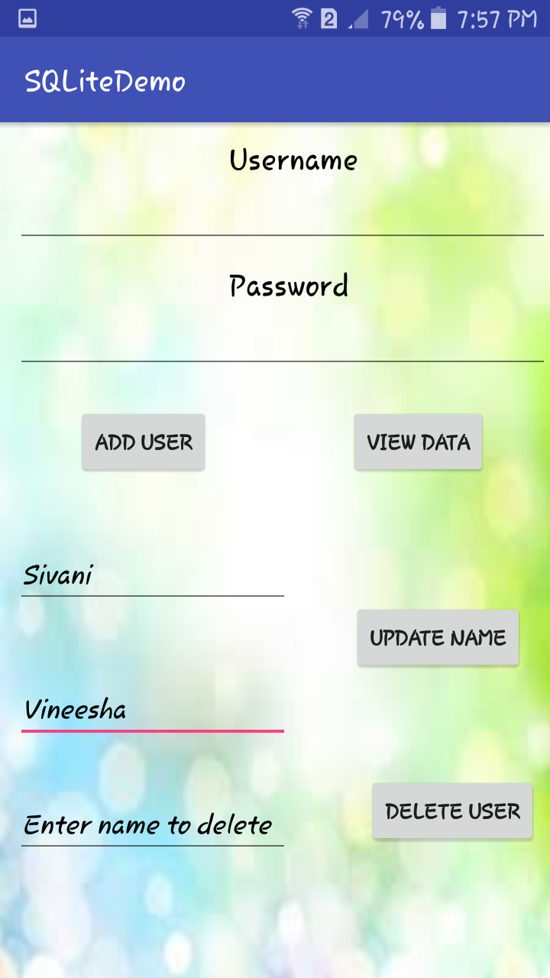 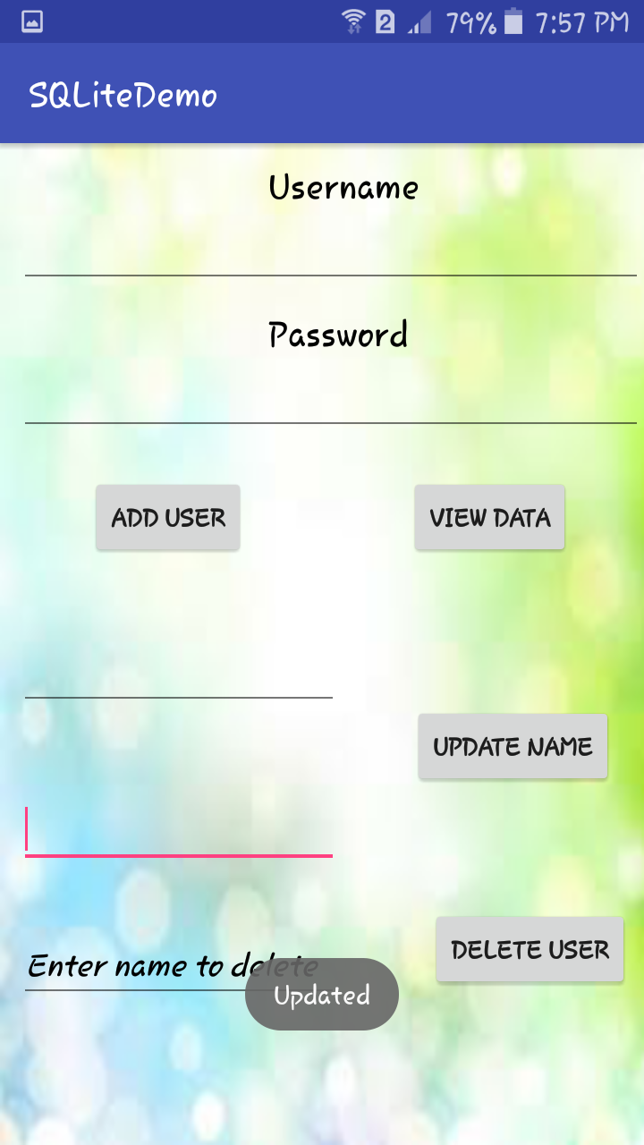

And now click on **VIEW DATA** to see the change in data displayed as a Toast.

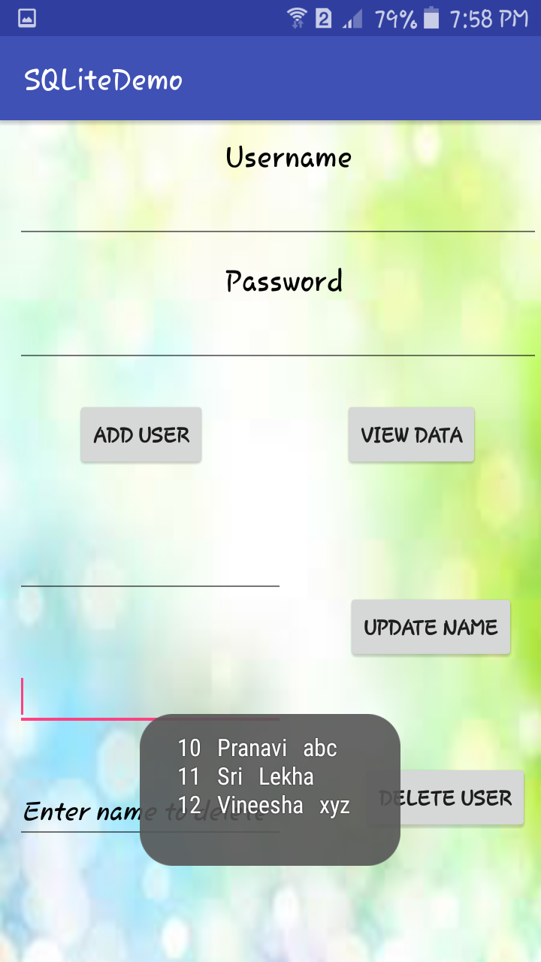

# **Retrofit**

In Android, Retrofit is a REST Client for Java and Android by Square inc under Apache 2.0 license. Its a simple network library that used for network transactions. By using this library we can seamlessly capture JSON response from web service/web API. It’s easy and fast library to retrieve and upload the data(JSON or any other structured data) via a REST based web service. . In Retrofit you configure which converter is used for the data serialization. Typically for JSON you use GSon, but you can add custom converters to process XML or other protocols. Retrofit uses the OkHttp library for HTTP requests.

Using Retrofit

To work with Retrofit you need basically three classes.

* Model class which is used to map the JSON data to
* Interfaces which defines the possible HTTP operations
* Retrofit.Builder class - Instance which uses the interface and the Builder API which allows defining the URL end point for the HTTP operation.

Every method of an interface represents one possible API call. It must have a HTTP annotation (GET, POST, etc.) to specify the request type and the relative URL. The return value wraps the response in a Call object with the type of the expected result.

Retrofit Converters

Retrofit can be configured to use a specific converter. This converter handles the data (de)serialization. Several converters are already available for various serialization formats.

To convert to and from JSON:

* Gson: com.squareup.retrofit:converter-gson
* Jackson: com.squareup.retrofit:converter-jackson
* Moshi: com.squareup.retrofit:converter-moshi

To convert to and from Protocol Buffers:

* Protobuf: com.squareup.retrofit:converter-protobuf
* Wire: com.squareup.retrofit:converter-wire

To convert to and from XML:

* Simple XML: com.squareup.retrofit:converter-simplexml

Need of Retrofit In Android:

We have a lot of network libraries that used to fetch and send the data from/to server. In our previous article we use Volley library for network transactions but Retrofit is an ultimate replacement of Volley and all other libraries. Retrofit is better alternative of other libraries in terms of performance, ease of use, extensibility and others.

Difference Between Retrofit and other libraries:

In Android, retrofit library is different from other network libraries because it gives us an easy to use platform through which we don’t need to parse JSON responses as they are done by library itself. It used GSON library in the background to parser the response data. What we need to do is define a POJO (Plain Old Java Object) to parse the response.

Performance benchmarks for Android AsyncTask, Volley and Retrofit (in milliseconds, lower value is better):

Here is the main difference between our three mainly used techniques for implementing API’s is our android app. You can see the difference in performance that for one discussion means for one network request and response they will take how much time.

1. AsyncTask:

* one(1) discussion: 941 ms
* Seven(7) discussions: 4539 ms
* Twenty Five(25) discussions: 13957 ms

2. Volley:

* one(1) discussion: 560 ms
* Seven(7) discussions: 2202 ms
* Twenty Five(25) discussions: 4275 ms

3. Retrofit:

* one(1) discussion: 312 ms
* Seven(7) discussions: 889 ms
* Twenty Five(25) discussions: 1059 ms

Steps to Integrate Retrofit in our Android Studio Project.

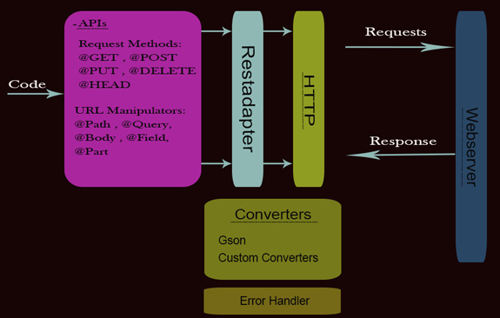

**RETROFIT APP**

Gradle and Dependencies

In Android Studio, Gradle is a custom build tool used to build android packages (apk files) by managing dependencies and providing custom build logic. APK file (Android Application package) is a specially formatted zip file which contains. Byte code. Resources (images, UI, xml etc). Gradle can be described a structured building mechanism where it provides a developer the tools and flexibility to manage the resources of a project to create builds that are smaller in size, targeting specific requirements for certain devices of certain configurations

Android Studio downloads the library from Maven Repository Server we defined in build.gradle. (Apache Maven is a tools developed by Apache provides a file server to distribute the libraries). Basically there are just 2 standard servers used for host the libraries for Android such as jcenter and Maven Central.

To use Maven Central in your project, you have to define the repository like below in project's build.gradle file.

Android Studio will import the library into your project. It will sync gradle files. Add the imported module to your project's dependencies. Right click on the app folder -> Open Module settings -> go to the dependencies tab -> Click on the '+' button -> click on Module Dependency.

Click on Build -> Edit Libraries and Dependencies.

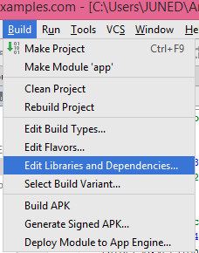

app -> Dependencies -> Click on small + button.

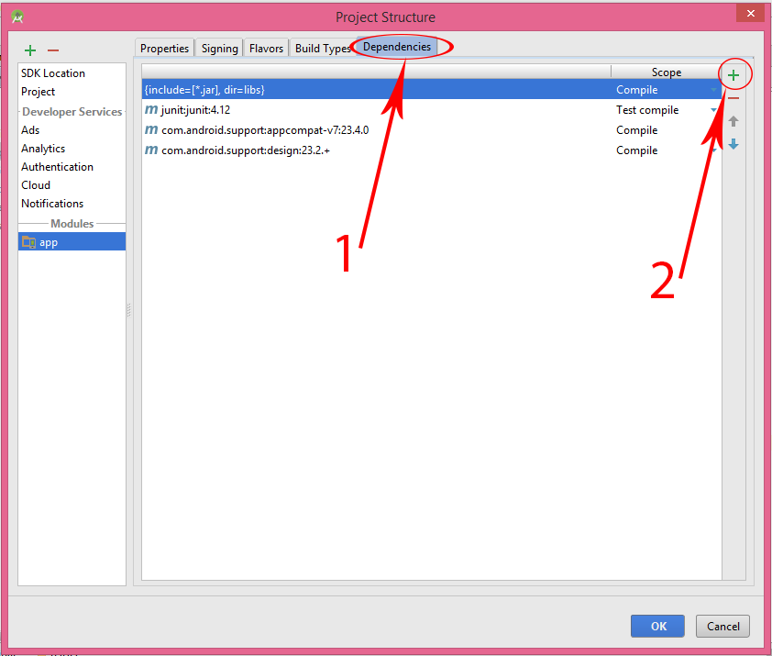

Click on Library Dependency.

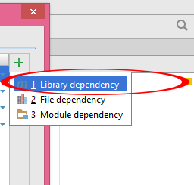

Here you go now all available inbuilt libraries will be display on your screen now select them and add them inside your project.

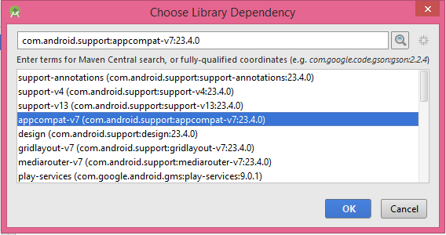

Gradle makes easy to include external binaries or other library modules to your build as dependencies. The dependencies can be located on your machine or in a remote repository, and any transitive dependencies they declare are automatically included as well. Dependencies are usually managed at the Module-level inside dependencies block in build.gradle file.

To add a dependency to your project, specify a dependency configuration such as implementation in the dependencies block of your build.gradle file.

JSON

JSON stands for JavaScript Object Notation.It is an independent data exchange format and is the best alternative for XML when our android app needs to interchange data from server. XML parsing is very complex as compare to JSON parsing.

JSON is shorter, quicker and easier way to interchange data from server. JSON is great success and most of the API available support JSON format.

Android provides four different classes to manipulate JSON data. These classes are JSONArray,JSONObject,JSONStringer and JSONTokenizer.

The API

The URL that gives us some data or to some task upon sending an HTTP request is called an API. And for this example, I already have an API, so you do not need to create the API. Below is our API URL.

https://simplifiedcoding.net/demos/marvel/

If you go to the above URL, you will get a response as shown below.

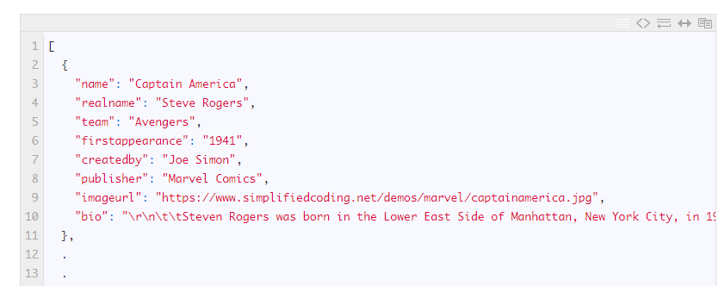

JSON Elements In Android:

In Android, JSON consist of many components. Below we define some common components.

1. Array([): In a JSON, square bracket ([) represents a JSONArray. JSONArray values may be any mix of JSONObjects, other JSONArrays, Strings, Booleans, Integers, Longs, Doubles, null or NULL. Values may not be NaNs, infinities, or of any type not listed here.

2. Objects({): In a JSON, curly bracket ({) represents a JSONObject. A JSONObject represents the data in the form of key and value pair. JSONObject values may be any mix of other JSONObjects, JSONArrays, Strings, Booleans, Integers, Longs, Doubles, null or NULL. Values may not be NaNs, infinities, or of any type not listed here.

3. key: A JSONObject contains a key that is in string format. A pair of key and value creates a JSONObject.

4. Value: Each key has a value that could be primitive datatype(integer, float, String etc).

GSON

Gson is a Java library that can be used to convert Java Objects into their JSON representation. It can also be used to convert a JSON string to an equivalent Java object.

Gson is an Open Source project, which can be found under https://github.com/google/gson The webpage provides a convenient download link.

Gson can work with arbitrary Java objects including pre-existing objects that you do not have source-code of. For this purpose Gson provides several built in serializers and deserializers. A serializer allows to convert a Json string to corresponding Java type and a deserializers allows to convert from Java to a JSON representation. You can also configure Gson to use custom representations of your objects.

Gson allows to serialize a Collections of objects of the same type. As the generics information is persisted in the JSON you need to specify the type to which you want to serialize too. For this you have different options.

To use Gson in a Gradle build, add compile 'com.google.code.gson:gson:2.6.2' or a later version as dependency to your build.gradl e build file.

Creating a new Project

Lets first create a new Android Studio Project. I have created a project named RetrofitExample.

Once the project is created we need to add the following two libraries to our project.

* Retrofit -> For the network calls
* Gson -> For easy parsing of JSON data

Adding Retrofit and Gson

Adding libraries are very easy. You just need to add the following two lines inside the dependencies block of your app level build.gradle file.

implementation 'com.squareup.retrofit2:retrofit:2.3.0'

implementation 'com.squareup.retrofit2:converter-gson:2.2.0'

Add Internet Permission in the AndroidManifest.xml:

For network transactions we need to define Internet permission in our Manifest file.

<manifest xmlns:android="http://schemas.android.com/apk/res/android"

package="com.abhiandroid.retroiftexample">

<uses-permission android:name="android.permission.INTERNET" />

<application>

After adding the lines just sync your project and you are done.

Creating API Interface

To make an API call using retrofit we need a java interface where we define all the URLs with the http request type and parameters. In this example we need to perform an http GET with no extra parameters.

So lets create a java interface inside and name it Api.java

As you can see we have a very simple interface above. Inside the interface first we have a BASE_URL. It contains the ROOT URL of our API. For any project we make an API like myproject/api/v1/apiname. Retrofit divides it in two parts the first part is the base URL and then the api name. So in our example marvel is the api name and before it we have the BASE URL.

After the base URL we have an annotation @GET(“marvel”). It means that we are defining an http GET request. And the String passed inside the get is the api name. So for this GET it will make the complete URL joining the BASE_URL and the api name.

Then we have a method named getHeroes() whose return type is Call. And the type of the Call is a List<>. And type of the List is Hero. It may sounds confusing but it is not. Actually we need to structure the api call according the the response. So our URL is giving us an json array and that is nothing but a list of heroes. So we defined the Call type as a List and the List type as Hero. Now we need to define the Hero class.

The Model Class

Annotations are a class of metadata that can be associated with classes, methods, fields, parameters and even other annotations. They can be accessed at runtime — using reflection — and/or at compile time using annotation processors.

In addition to the already built-in java annotations, Android, through the android support library provides additional annotations.

Lets create a class named Hero. It will be a simple java class with a constructor and getters. And inside this class we will define all the attributes of our response.

Make sure your variable names matches with the JSON attributes. As we have the following JSON objects in our response.

So for getting this name we have to name our String as name (case sensitive) in the model class.

So if you put the annotation @SerializedName(“attribute name”) with the json attribute name just above every variable you are defining, you can name your variables anything but you have to put the correct attribute name inside SerializedName(“name”). These fields are annotated with the @SerializedName annotation. The parameter (value) of this annotation is the name to be used when serialising and deserialising objects.

For example, the Java field private String name is represented as name in JSON.

We Generate a Constuctor for the declared variables, and generate the Getter and Setter methods

Making the API Call in MainActivity.java

Retrofit retrofit = new Retrofit.Builder()

.baseUrl(Api.BASE_URL)

.addConverterFactory(GsonConverterFactory.create()) //Here we are using the GsonConverterFactory to directly convert json data to object

.build();

Api api = retrofit.create(Api.class);

Call<List<Hero>> call = api.getHeroes();

call.enqueue(new Callback<List<Hero>>() {

Now the final step is performing the API call and Fetching the JSON Data

Displaying the Heroes in a ListView

Creating Interface

Come inside activity_main.xml of your project and create a ListView.

Thats it now you can play your application.

**OUTPUT:**

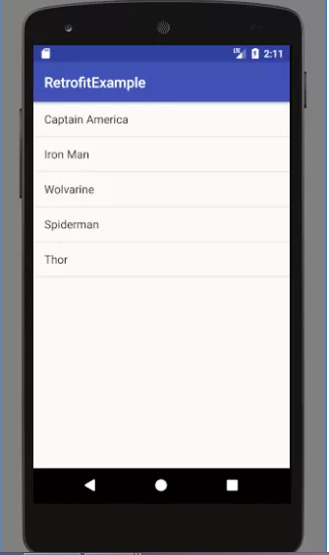

**RETROFIT IMAGES WITH GLIDE AND RECYCLERVIEW**

Android Pagination with RecyclerView, using real data from an API. This will give us a better understanding of Pagination. First, we’ll look at what API to use. Next we will setup a networking library (Retrofit) that will help us perform these API calls.

We need an API key. Generate an API key from there site or server.

I recommend using [Postman](https://www.getpostman.com/) when dealing with APIs. It gives you a clear idea on how to construct proper API requests. Also, the formatted JSON response is handy too.

Before we begin, we’ll need to decide upon a networking library (and image loading library too, if you wish). Dealing with text and media in APIs is pretty common, so I’ll assume we need both. These libraries will do most of the heavy-lifting, allowing us to focus on the app itself.

**Tech Stack:**

1. [Gson](https://www.themoviedb.org/account/signup) – library to convert Java Objects into their JSON representation and back
2. [Retrofit](https://github.com/square/retrofit) – HTTP client for Android
3. [Glide](https://github.com/bumptech/glide) – image loading and caching library for Android; handy for smooth scrolling

You might be familiar with Retrofit and Gson. They’re a powerful combination, often preferred when dealing with APIs. The Codepath guides is a perfect place to start for the uninitiated:

* [Consuming APIs with Retrofit](https://guides.codepath.com/android/Consuming-APIs-with-Retrofit)
* [Leveraging the Gson Library](https://guides.codepath.com/android/Leveraging-the-Gson-Library)

GLIDE

Glide is an Image Loader Library for Android developed by bumptech and is a library that is recommended by Google. It has been used in many Google open source projects including Google I/O 2014 official application. It provides animated GIF support and handles image loading/caching.

Glide can do the job in one line and is a nice wrapper for an HTTP client. Glide uses HttpUrlConnection as its default network stack. Two other key benefits of Glide are, smoother loading when scrolling through a view that contains images and perhaps more importantly, animated GIF support.

Glide offers some additional advantages over other image loading libraries. For example, when loading an image, Glide will cache both a version of the image in its original size as well as one that’s the size of its intended ImageView. This means Glide loads the image noticeably faster than libraries like Picasso because no resize is necessary. Additionally, Glide works with Android’s ImageView. Normally, this wouldn’t bear mentioning except that a number of libraries do not work with ImageView. For example, Facebook’s Fresco uses DraweeView and Volley uses NetworkImageView. Glide doesn’t deviate from the standard ImageView so it is easier to begin using.

It’s important to keep in mind that Glide requires Android’s Support Library v4, so support-v4 needs to be imported along with Glide itself.

Add to your app/build.gradle file:

dependencies {

implementation 'com.github.bumptech.glide:glide:4.7.1'

// Glide v4 uses this new annotation processor -- see https://bumptech.github.io/glide/doc/generatedapi.html

annotationProcessor 'com.github.bumptech.glide:compiler:4.7.1'

}

RECYCLERVIEW

In Android, RecyclerView is an advanced and flexible version of ListView,GridView and CardView. It is a container used for displaying large amount of data sets that can be scrolled very efficiently by maintaining a limited number of views. RecyclerView was introduced in Material Design in API level 21 (Android 5.0 i.e Lollipop).

This new widget is a big step for displaying data in Material Design because the ListView,GridView and CardView are one of the most commonly used UI widget. In RecyclerView android provides a lots of new features which are not present in existing ListView,GridView and CardView.

Important Note:

In Android, RecyclerView provides an ability to implement the horizontal, vertical and Expandable List. It is mainly used when we have data collections whose elements can change at run time based on user action or any network events. For using this widget we have to specify the Adapter and Layout Manager.

Gradle Dependency to use RecyclerView:

The RecyclerView widget is a part of separate library valid for API 7 level or higher. Add the following dependency in your Gradle build file to use recyclerview.

Gradle Scripts > build.gradle and inside dependencies

dependencies {

...

compile "com.android.support:recyclerview-v7:23.0.1"

}

Make sure to sync your project to Gradle before continuing on.

RETROFIT

Retrofit is a HTTP client library by Square Inc. It makes networking easier and also easy to implement.

Retrofit is an excellent library to load data from an API or website. Parsing the JSON Data using Android Retrofit API and display in Recyclerview with Cardview.

Retrofit 2 requires a dependency for the automatic conversion of request and response payloads. Use the following dependencies if you’re using Retrofit in version 2 and want to map JSON payloads with GSON:

build.gradle

dependencies {

// Retrofit & OkHttp

compile 'com.squareup.retrofit2:retrofit:2.3.0'

compile 'com.squareup.retrofit2:converter-gson:2.3.0'

}

CARDVIEW

CardView is another major element introduced in Material Design. Using CardView you can represent the information in a card manner with a drop shadow (elevation) and corner radius which looks consistent across the platform. CardView extends the FrameLayout and it is supported way back to Android 2.x.You can achieve good looking UI when CardView is combined with RecyclerView.

add the CardView dependency in build.gradle and Sync the project.

build.gradle

dependencies {

// CardView

compile 'com.android.support:cardview-v7:23.3.+'

}

FRESCO DRAWEEVIEW

Fresco is a powerful library for displaying images in Android, supporting applications all the way back to GingerBread (API 9). It downloads and caches remote images in a memory efficient manner, using a special region of non-garbage collected memory on Android called ashmem.

* Drawee - Drawees deal with rendering images on screen and are made up of 3 parts.
* DraweeView - The view that shows the image. It extends from ImageView, but only for convenience (see the gotchasbelow for more info on this). Most of the time you'll be using a SimpleDraweeView in your code.

com.facebook.drawee.view.DraweeView<DH extends com.facebook.drawee.interfaces.DraweeHierarchy>

Adding internet permissions in AndroidManifest.xml

<uses-permission android:name="android.permission.INTERNET”/>

Creating Layout -> activity_lifestyle.xml

Creating activity_lifestyle.xml file inside Layout folder which contains recyclerview widgets and cardview.

lifestyle_list.xml

Creating Layout -> lifestyle_list.xml

Creating list.xml the file inside Layout folder which contains card view widget. lifestyle_list.xml file will renderer in Recyclerview. Nested LinearLayout will contain the 3 TextViews and 1 ImageView.

Creating Interface -> OfferService.java

Create an interface name it “OfferService.java” and use annotation “@GET” inside the interface to get the response from the API. Create getOfferList() method. Here we will use the end part the API URL in GET Annotation.

BASE_URL="http://172.15.25.50:8080/VideoMaster7/user/";

@GET("video")

Call<OfferList> getOfferList();

Creating POJO Class > Offer.java

POJO means Plain Old Java Object. It refers to a Java object (instance of definition) that isn't bogged down by framework extensions.It is nothing but the Model class in another terms.

An Annotation object is used as a wrapper for a text attribute value if the attribute has annotation characteristics. These characteristics are:

The text range that the attribute is applied to is critical to the semantics of the range. That means, the attribute cannot be applied to subranges of the text range that it applies to, and, if two adjacent text ranges have the same value for this attribute, the attribute still cannot be applied to the combined range as a whole with this value.The attribute or its value usually do no longer apply if the underlying text is changed. These fields are annotated with the @SerializedName annotation. The parameter (value) of this annotation is the name to be used when serialising and deserialising objects.

JSON has become the defacto standard of data exchange on the web. Compared to its cousin XML, it is smaller in size and faster to both create and parse. In fact, it seems so simple that many developers roll their own code to convert plain old Java objects or POJO to and from JSON. For simple objects, it is fairly easy to write the conversion code, but as your objects grow more complex, your code’s complexity grows as well.

There are quite a few alternatives to writing your own Java JSON serializer/deserializer; in fact, json.org lists 25 of them. One of them, Gson, was created by Google for use on internal projects and later was open sourced. Gson is hosted on Google Code and the source code is available in an SVN repo.

The process of converting POJO to JSON is called serialization. The reversed process is deserialization. A big reason that GSON is such a popular library is how simple it makes both processes. For both, the only thing you need is the Gson class.

Create a POJO class name it Offer.java file and declare the offer related variables and which contains offer-related getter and setter methods and constuctor after generation automatically. So let’s auto-generate our model classes and save ourselves time.

Configuring Retrofit in RetrofitClient.java and We will define all our API calls here. Retrofit uses Annotations to define API calls by Creating the Retrofit instance to send out network requests to an API, we need to use the Retrofit builder class and specify the base URL forthe service. Remember that the base URL must always end with a forward trailing slash.

Making API Calls with OfferList.java Retrofit Now we’re going to perform the API request here.

Start by initialising OfferService object with a Retrofit instance. Look at getOfferitems() method in OfferList.java, you’ll notice that it builds a configured Retrofit instance and returns the Retrofit API call since we’ll be reusing the same. The method parameters passed here are query parameters for the API’s URL.

Another helper method that extracts the list of results from the API response.

Now create Adapter for the implementation of API’s that is OfferAdapter.java

VIEWHOLDER

ViewHolders belong to the adapter. Adapters should feel free to use their own custom ViewHolder implementations to store data that makes binding view contents easier. Implementations should assume that individual item views will hold strong references to ViewHolder objects and that RecyclerView instances may hold strong references to extra off-screen item views for caching purposes. If you’ve used a RecyclerView, you may know that they don’t have a setOnItemClickListener as ListView had, so we have to create our own way to do it. Many people asked me how to do this, so that’s why I decided to write about it.

There are many ways to achieve this, but I will show you the way I usually do it. My mechanism consists of passing the listener as a parameter to the constructor and then assign it when I bind the data to the view in onBindViewHolder.

You’ll first need an interface that specifies listener’s behaviour. In this example, there is a sample model called ContentItem, so the click will return an item of that type. The constructor will receive an object that implements this interface, along with the items to be rendered.

MainActivity.java will consist of the ContentView to activity_main Layout to display the final output

**OUTPUT:**

The output requires internet in mobile phone or PC Emulator. The URL is linked to a server and the server has to be online then only this Retrofit App will work.

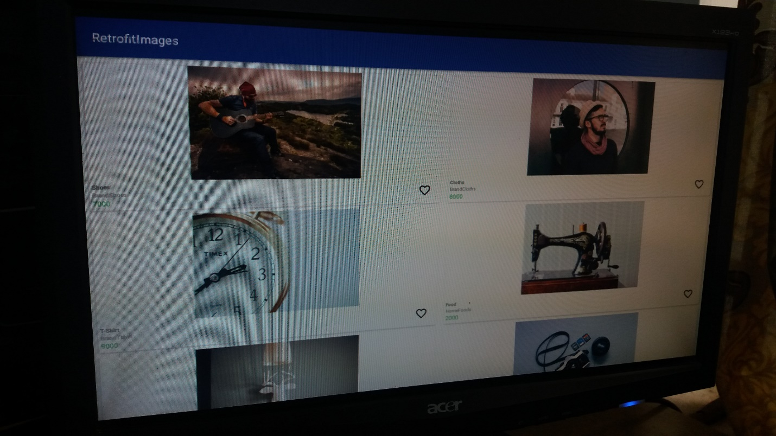

# **Navigation Drawer and Swipe Tabs**

Navigation Drawer

Navigation Drawer is a panel that displays App’s Navigation option from the left edge of the screen. It is one of the most important and useful UI pattern introduced by the Google for developing Android app.Navigation drawer is a side menu that helps us to organise the navigation inside our app. It is a uniform way to access different pages and information inside our app. It is hidden most of the time but is revealed when we swipes from left edge of the screen or whenever we click on menu/app icon in the action bar.

Need of Navigation Drawer:

We might have noticed that lot of our Android Applications introduced a sliding panel menu for navigating between major modules of our application. This kind of UI was done by using third party libraries where a ListView and swiping gestures used to achieve this type of UI. But now Android itself officially introduced sliding panel menu by introducing a newer concept called Navigation Drawer. In Navigation Drawer we combine NavigationView and DrawerLayout to achieve the desired output. The navigation drawer opens nicely by touching the hamburger icon on the top left screen.

DrawerLayout

DrawerLayout acts as top level container for window content that allows for interactive “drawer” views to be pulled out from one or both vertical edges of the window. Drawer position and layout is controlled by using layout_gravity attribute on child views corresponding to which side of view we want the drawer to emerge from like left to right. we’ll implement the navigation drawer using the Drawer Layout API present in Android Support Library.

TabLayout

TabLayout is a new element introduced in Design Support library. It provides horizontal layout to display tabs on the screen. We can display more screens in a single screen using tabs. We can quickly swipe between the tabs. TabLayout is basically view class required to be added into our layout(xml) for creating Sliding Tabs. We use different methods of TabLayout to create, add and manage the tabs.

TabLayout is used to display tabs on the screen. We can create sliding as well as non sliding tabs by using TabLayout. If we need simple tabs without sliding then we replace the layout with the fragment on tab selected listener event and if we need sliding tabs then we use Viewpager.

ViewPager

ViewPagers are used to swipe through pages of data. It’s generally used in conjunction with fragments. ViewPager in Android allows the user to flip left and right through pages of data. In our android ViewPager application we’ll implement a ViewPager that swipes through three views with different images and texts.

Navigation drawer with swipe tabs involves working with nested fragments.Basically, the fragment inflated by navigation drawer will in-turn inflate tab fragments.We will use the Design Support Library to create an android app with Material design Navigation Drawer and Swipe Tabs.

Adding required dependencies.

Open your build.gradle(Module: app) file and add the below dependencies.

1) implementation ‘com.android.support:design:25.3.1’

2) implementation ‘com.android.support:appcompat-v7:25.3.1’

3) implementation fileTree(dir: 'libs', include: ['*.jar'])

implementation: you only use this module internally and does not leak it through your interfac

In this location res=>values=>style.xml We can Customize your theme here and This is to remove the default action bar, so that we can use our custom implementation of toolbar

In this location res=>values=>color.xml We can Customize colors

Create navigation_drawer_menu.xml in res=>menu This resource will basically, hold the items to be inflated in the NavigationDrawer.

In nav_header.xml This is the header section of the navigation drawer.

Create a new toolbar in activity_main.xml Layout.

Now, lets design our main layout. This is basically a drawerLayout which holds two child elements.

1)LinearLayout : To hold our toolbar and frameLayout. FrameLayout is used to hold contents inflated by fragments of navigation drawer items.

2)NavigationView: This is our navigationDrawer. Here, we use our menu resource created in step 1 to add elements in to the drawer. Also, we add our optional header here itself.

Checkout the below flow of the layout:

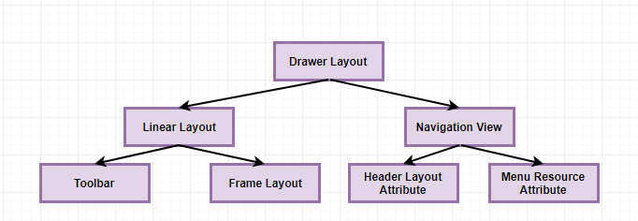

This toolbar will act as our ActionBar. A toolbar is basically a way more flexible element than the default ActionBar and it is not the part of window decor. Also, It can can be placed anywhere within view hierarchy.

FrameLayout

Frame Layout is designed to block out an area on the screen to display a single item. Generally, FrameLayout should be used to hold a single child view, because it can be difficult to organize child views in a way that's scalable to different screen sizes without the children overlapping each other that is Navigation Drawer and Tab Layout.

Create Layouts and add Textview to display the message of each layout accordingly.They are

* auto_tab_layout.xml
* bookmark_layout.xml
* lifestyle_tab_layout.xml

Creating our Tab layout:

Now, lets create the tab layout that will be inflated by one of the fragments of navigationDrawer.

This basically has two elements contained in a LinearLayout:

1)TabLayout: This provides a horizontal layout to display tabs. We can define both fixed as well as scroll-able tabs. With fixed size, your tabs will shrink to occupy just the device’s width. With scroll enabled, there’s no shrink, you can scroll through them.

2)ViewPager: This is used to provide data to screen slides.There is an inbuilt animation, which shows the transition from one page to another.We can use this in conjunction with tabs to get the desired effect.

This make our Application layout look something like below:

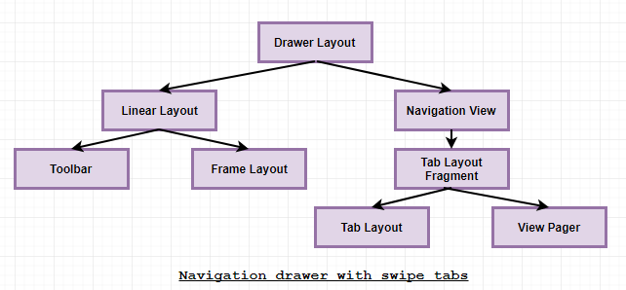

Creating a new fragment which populates the above layout.

* AutoTabFragment.java
* LifeStyleTabFragment.java
* ExpoTabFragment.java
* BookmarkFragment.java

Now, create a new fragment. This is inflated by our tabs, which uses the above created layout as its view. This is a super simple fragment created for demo purposes. Inflate gives you the object reference to that layout to call findViewById on. LayoutInflater is used to manipulate Android screen using predefined XML layouts. This class is used to instantiate layout XML file into its corresponding View objects. It is never used directly.

Create a new fragment to inflate the tab layout in HomeFragment.java

This fragment inflates a tab layout created in the above step. Here, we set up our tabLayout and pageViewer. We also create a new class inside this fragment, which acts like adapter to our pageView. This adapter overrides three mandatory methods:

1)getItem : This returns the fragment with respect to the position of the page.

2)getCount : The total count of pages/tabs.

3)getPageTitle: This returns the title of the page according to the position.

Here, we also define a setOffscreenPageLimit. This basically preloads the adjecent tabs. Like if you are on page 2, this will keep pages 1 and 3 loaded in memory. Without this, the transition isn’t smooth and lags a bit.

Here we code our MainActivity.java where we wind everything up. We setup our NavigationView,DrawerLayout and toolbar here. This is fairly easy to understand, we just initialize all the sutff created in activity_main.xml and set up our navigationDrawer to inflate fragments according to menu item selected.

Also, define strings R.string.drawer_open and R.string.drawer_close in your strings.xml file with some appropriate descriptions. These are not used anywhere in the App, it is for accessibility to help out visually impaired users. Basic material design style drawer filled with navigation items that switch different fragments into the content area. In this way, you can define multiple fragments, and then define the list of options which will display in the drawers items list. Each item when clicked will switch the relevant fragment into the activity's container view. Setup a handler to respond to click events on the navigation elements and swap out the fragment. This can be put into the activity directly.

**OUTPUT:**

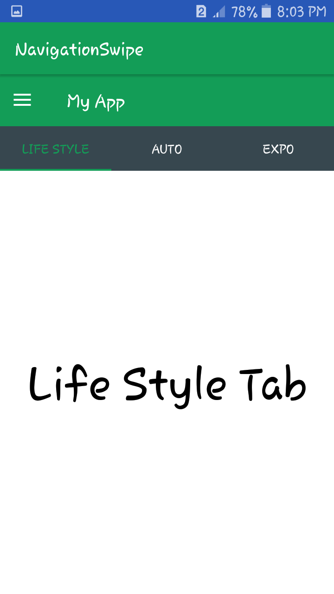

Swipe to AUTO and Auto Tab will be opened.

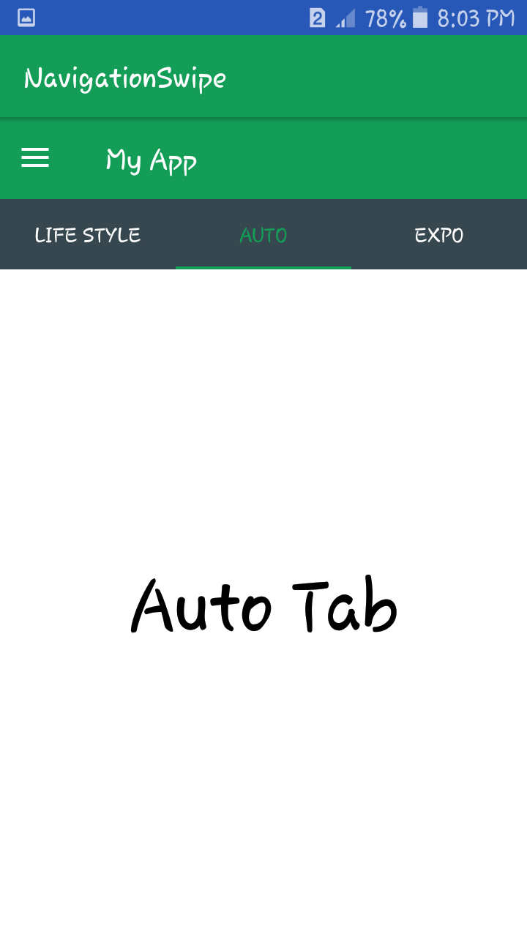

Swipe to EXPO and Expo Tab will be opened.

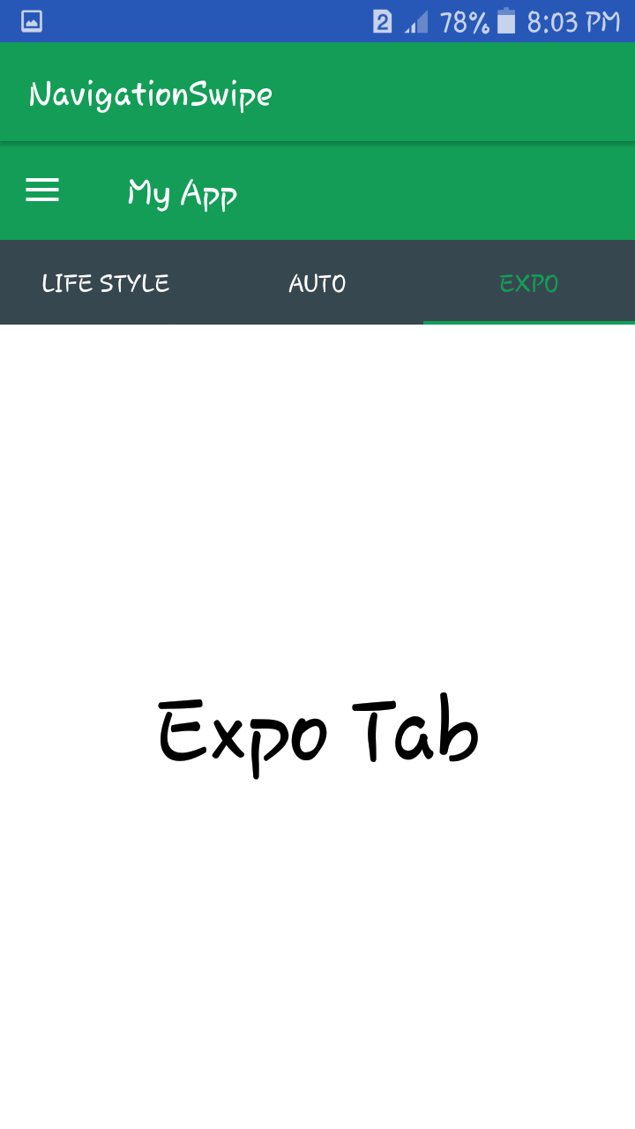

Click on the Hamburger Icon on the left side of the Screen and the Navigation Menu will open.

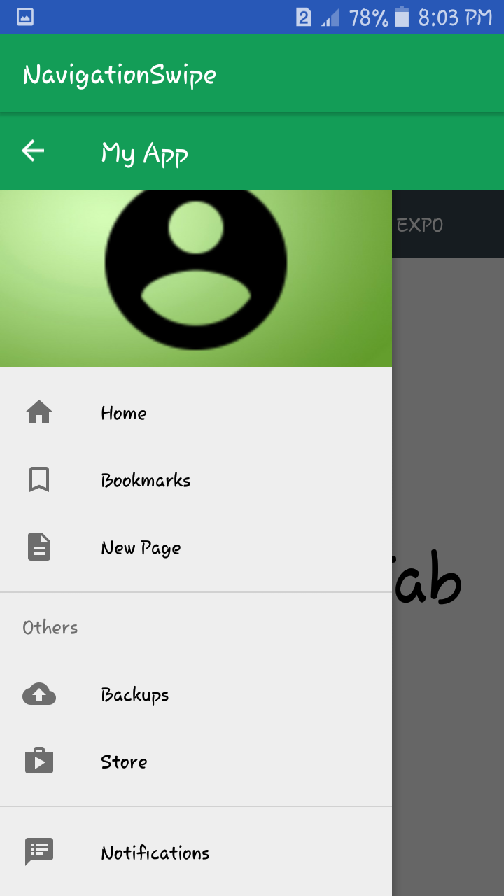

Click on the Bookmarks and you will be directed to the Bookmark Tab.

